Solent University

Computing | Science & Engineering

**Software Engineering**

**2023 - 2024**

**Boldizsar Banfia**

**“How effective are technological interventions, particularly social media applications designed for creating genuine social connections, in reducing feelings of loneliness among users?”**

Supervisor : Name of your supervisor

Date of submission : May 2024

# Acknowledgements

Write a paragraph here acknowledging everyone who has helped you while you have been preparing the content of your dissertation.

This may be you supervisor or other academic staff that have provided guidance and support, other students or colleagues with whom you have collaborated on any research or project work, interviewees, librarians, or perhaps any external bodies that have given you assistance, such as access to data or the opportunity for hands on experience.

# Abstract

This should clarify to the reader why they should read your report, Abstracts are a short summary, one paragraph 300 words max. giving a snapshot of your entire project; why, how, results and conclusions/ recommendations. The Abstract needs to work as a “standalone” so avoid using any citations. Write your abstract last.

Table of Contents

Acknowledgements i

Abstract ii

1. Introduction 4

2. Literature Review 5

2.1 Sub Section 5

2.2 Sub Section 5

3. Methodology 6

3.1 Methods Section 6

3.2 Methods Section 6

3.3 Professional, Legal and Ethical issues 6

3.3 Project Management 6

4. Design & implementation 7

5. Results 8

6. Conclusions 9

7. Recommendations 10

8. Reference list 11

9. Bibliography 12

10. Appendices A

Appendix A: Title A

Appendix B: Title B

Appendix C: Title C

NOTE: This contents page has been automatically generated from headings formatted in the main document. Use Heading 1 for the title of new sections, Heading 2 for the title of new sub-sections and so on throughout the document. Once you have added your content, click on the contents table below and select ‘update table’ to see changes. There is no need to edit the list directly.

The tables and figures list on the next page has been automatically generated in the same manner. Each time you add a new item in the main document, go to the ‘references’ menu and select ‘insert caption’ to create the title of the table or figure. Then update the tables and figures list for the new items to appear.

You might wish to add a section for **Project Specification/Requirements** after **the Literature Review** if you are doing a **software product/build** type of project

**List of Figures**  
**Figure 1: Four sprints of the development.**

Figure 2: The logo of the project.

Figure 3: The main four containers.

Figure 4: Snippet of server code directory.

Figure 5: Snippet of the images route.

Figure 6: Snippet of a Model.

Figure 7: Diagram of the how unstructured became structured.

Figure 8: Diagram explaining redux.

Figure 9: Snippet of fetch and redux function used simultaneously.

Figure 10: Snippet of a docker file.

Figure 11: Snippet of NGINX settings.

Figure 12: Snippet of domain

Figure 13: Diagram of the deployed version’s containers of the project

Figure 14: Snippet of the home page.

Figure 15: Snippet of file structure

Figure 16: Diagram of the cookie implementation

Figure 17: Snippet of current user’s profile

Figure 18: Snippet of plans page

Figure 19: Code snippet of the Haversine formula

Figure 20: Code snippet of city conversion to geolocation

Figure 21: Snippet of the chat page

Figure 22: Diagram of Socket io implementation

Figure 23: Diagram of notification logic

Figure 24: Snippet of interest and location modal

Figure 25: Code snippet of a matching controller

Figure 26: Diagram of proximity logic

Figure 27: Snippet of the radius modal

Figure 28: Snippet of swiping logic

Figure 29: Snippet of matches

Figure 30: Diagram of vectorization

Figure 31: Diagram of steps taken by chatbot

Figure 32: Diagram of Swagger logic

Figure 33: Snippet of test directory

Figure 33: Diagram of deployment

Figure 34: Diagram of password criteria

Figure 35: Diagram of JWT logic

Figure 36: Diagram of reset password logic.

Figure 37: Diagram of password reset in the back-end.

# Acronyms

* **API – Application Programming Interface**
* **CSS – Cascading Style Sheets**
* **HTTPS – Hyper Text Transfer Protocol Secure**
* **JSON – JavaScript Object Notation**

# 1. Introduction

As humans, we possess an intrinsic need to belong. This includes feeling part of a group, forming connections with others, and engaging in positive social interactions with those around us (Moreton et al., 2019). The notion of enduring, positive interpersonal bonds lies at the core of Baumeister and Leary's (1995) belongingness hypothesis. The theory posits that human beings have a basic drive to form and sustain meaningful social connections and relationships with others in their environment. This fundamental need for belongingness is considered a powerful motivational force underpinning much of human behaviour and psychosocial functioning. This need is exemplified by findings indicating that humans not only spend 80% of their waking hours in the company of others but also derive more enjoyment from these interactions than from solitary endeavours (Yrian Derreumaux et al., 2021). These findings underscore the central role that interpersonal relationships play in shaping our identity and well-being. However, if these needs for belongingness are not adequately met, an individual is likely to experience loneliness (Allen and Furlong, 2021).

In an increasingly digital age, the prevalence of loneliness has emerged as a significant public health concern, especially among the global population transitioning towards more solitary lifestyles. This phenomenon is exacerbated by rapid urbanization, evolving family structures, and the shifting dynamics of how individuals interact socially (V. Blaginin, 2018). As a result, loneliness is not merely an individual ailment but a societal issue with far-reaching implications, including mental health disorders and decreased life satisfaction.

The paradox of our time is the simultaneous connectedness and isolation brought about by technology (Sima and Han, 2022). While social media platforms have the potential to connect billions of users worldwide, there is a growing perception that these technologies, rather than alleviating loneliness, might instead contribute to it. This raises the question of whether technology can be effectively harnessed to foster genuine social connections and mitigate feelings of loneliness. Therefore, this dissertation explores the efficacy of technological interventions, particularly those designed within social media applications, aimed at creating meaningful social interactions among users.

The purpose of this project is to evaluate the role of technological interventions in combating loneliness, specifically through the lens of social media platforms designed to enhance genuine social interactions. By understanding the capabilities and limitations of current technologies, this research aims to identify key elements that contribute to successful social connections and to recommend strategies for improving existing platforms and developing new ones.

The scope of this research encompasses various digital platforms, from traditional social media networks to emerging interactive applications that facilitate user interaction and engagement. This study delves into different technological strategies, such as algorithm-driven matching systems, real-time communication tools, and community-building features designed to enhance social connectedness.

The purpose of this project is to evaluate the role of technological interventions in combating loneliness, with a particular focus on social media platforms designed to enhance genuine social interactions. This research will explore the existing gaps in how digital tools address social isolation, setting the stage for an in-depth investigation into effective strategies that can foster meaningful connections.

The scope of this research encompasses various digital platforms, from traditional social media networks to emerging interactive applications that facilitate user interaction and engagement. This study delves into different technological strategies, such as algorithm-driven matching systems, real-time communication tools, and community-building features designed to enhance social connectedness.

This dissertation aims to provide a comprehensive analysis of current technological interventions and assess their effectiveness in fostering social bonds. By examining various platforms and user experiences, the research seeks to uncover the potential of social media as a beneficial tool in combating the pervasive issue of loneliness in modern society. Additionally, this study will consider the broader implications of these findings for designing future technological solutions that prioritize mental health and well-being.

# 2. Literature Review

2.1 The Evolutionary Basis and Societal Increase of Loneliness  
Research consistently affirms that loneliness is an integral element of human life (Cohen 2022; Heinrich and Gullone 2006; Cacioppo et al. 2013). It stems from our evolutionary imperative for social connection and belonging, shaping the survival and progress of humankind (Allen and Furlong 2021), which includes a sense of relatedness to others (Prescott 2023). The transition from communal living to personal autonomy has been linked to increased loneliness in the past two decades (Evans et al. 2022). The rapid growth of urban regions and the breakdown of traditional family structures contribute to the decline of mental health and the amplification of feelings of isolation (Anders Carlson-Wee 2023). Studies show the role of environmental and societal changes brought about by fast-paced economic development and high technology usage has been linked to elevated levels of stress and health problems, which in turn can contribute to a sense of isolation (Prakash et al. 2023; Afifi et al. 2018).

Research demonstrates a noticeable uptick in loneliness levels in recent years, despite the integration of standardized assessments of loneliness into ongoing panel studies in the past 15 years (Luhmann et al. 2023). It is substantially more acute in developed nations, leading with the United States (Infurna et al., 2024). Nonetheless, current U.K. government surveys reveal that nearly half the population reports feelings of loneliness (Gov.UK 2021). It has also been consistently demonstrated that the prevalence of this phenomenon is higher among younger adults and older adults (Wrótniak, 2020; Matthews et al., 2018). A recent cross-temporal meta-analysis by S. Buecker et al. (2021) underscores this trend and concludes that it is primarily influenced by societal and technological changes.

2.2 Ramifications of Prolonged Loneliness

Loneliness emerges from a misalignment between the desired social relationships of an individual and their current social circumstances (Registrar 2016). Chronic loneliness ranks among the most serious threats to overall well-being (Cacioppo and Patrick 2008). It is strongly linked with mental health disorders such as depression, anxiety, and heightened stress levels (Hoffart et al., 2020). Additionally, it significantly impacts social skills, leading to social withdrawal and a decline in social networks, thereby intensifying feelings of isolation (Gardner et al., 2005). Numerous studies have shown that loneliness can be as detrimental to health as smoking or obesity (Holt-Lunstad 2018; Beutel et al. 2017).

There are also societal repercussions, including a significant economic burden associated with loneliness. This burden manifests in increased healthcare utilization and reduced productivity due to mental health issues (Meisters et al. 2021). Various industries are also weaponizing this phenomenon, both directly and indirectly changing consumption preferences and modes (Wang and Liu n.d.), further fueling increasing materialism (Pieters 2013) and isolation.

2.3 Technological Interventions for Loneliness

Research indicates a pronounced emphasis on studies and interventions directed at older individuals compared to younger cohorts (Dickens et al. 2011). Although loneliness affects both age groups, the nature of the interventions provided varies; older adults are more frequently offered technology-based solutions tailored to their specific needs. On the other hand, younger individuals tend to utilize platforms that are not specifically designed to combat loneliness (Shah and Househ 2023). Social media is frequently regarded as an excellent platform for establishing connections (Berezan et al. 2019), and lonely people are more inclined to turn to these as a substitute for participating in offline social activities (Nowland et al. 2018). Although research presents varied outcomes, correct engagement with these platforms can negatively correlate with feelings of loneliness (Guo 2015). The digital landscape offers a multitude of features aimed at emulating interpersonal communication and promoting interconnectedness.

Transitioning from the broad use of social media to specific interactive features, chatting capabilities allow for instantaneous communication, resembling face-to-face interactions and bridging both geographical and interpersonal divides (Ong et al. 2011). Related research explores how virtual group identities on platforms like Discord can help reduce feelings of loneliness by providing a sense of belonging and social interaction (Rai et al. 2022).

Further enhancing the experience, platforms that enable users to express themselves more fully through sharing thoughts, experiences, and images can cultivate a feeling of inclusion. The feedback and responses received in response to these expressions can authenticate personal encounters and emotions (Deters & Mehl, 2012). A recent case study by MB Kelly, B Phillips, and CR Davies delves into the ways in which social media platforms such as Facebook and Instagram can enhance community involvement by encouraging shared interests like photography. The study emphasizes that social media art challenges not only encourage artistic engagement but also contribute to mental wellness by alleviating feelings of isolation through communal participation (Kelly et al., 2023). Moreover, most of these platforms are dedicated to fostering communities where individuals can engage with others who share similar interests, hobbies, or personal connections, thereby promoting connections among individuals with common interests (Smith and Alheneidi 2023). An illustrative study by Guidi et al. (2020) explores the dynamics of Facebook groups and their role in forming and sustaining communities. By analyzing how communities evolve within these groups, it reveals how individuals connect with others who share similar interests and beliefs.

Other types of applications facilitate connections among individuals, with dating and matching apps experiencing a notable increase in popularity. When used effectively, these applications not only create social opportunities but can also mitigate loneliness and ease emotional exhaustion (Sarwar Shah et al. 2019). A recent study by Nikki Dean Marshall et al. (2023) examines the impact of online dating platforms, such as Bumble BFF, in alleviating social isolation amidst the pandemic. It emphasizes the shift of users toward these platforms not only for romantic relationships but also for companionship and social engagement.

Another example of such technology includes therapeutic chatbots. Crafted to mimic companionship, they are increasingly deployed, especially among elderly populations, to alleviate loneliness and enhance mental well-being (Rebola and Malle 2021). Despite their growing numbers, they often face limitations due to cost and the lack of a personal touch in interactions. As a result, they may not fully replicate the empathy and connection found in human interactions. Recent research involving a randomized controlled trial examined the effectiveness of a therapeutic chatbot named Fido, which utilizes cognitive behavioral therapy techniques. The findings indicate that Fido was successful in reducing symptoms of anxiety and depression (Stanisław Karkosz et al. 2024).

2.3 Shortcomings

Despite the deep integration of various digital tools and platforms into our daily lives, social media can turn from a mitigating factor of loneliness to its very cause (Hasyim and Cuzzamu 2022). Being able to share things publicly can have positive effects, but the feedback the user receives does not necessarily equate to meaningful social engagement. While a recent study shows that receiving positive feedback after posting status updates, such as likes on social networking sites, predicts a lower level of loneliness (Sun et al. 2022), comments on posts, on the other hand, often catalyze arguments (Gkotsis et al. 2016). However, while digital interactions provide some level of social connection, they often lack the depth and authenticity of face-to-face interactions. This superficial engagement can lead to a paradox where users feel connected yet isolated at the same time (Chayko 2014). Social media overuse can adversely impact users in several ways, notably through a reduction in face-to-face interactions, which may in turn diminish the quality of relationships (Gupta et al., 2022; Mahmud et al., 2017). Rarely do most social media platforms include features that inherently benefit, support, or encourage in-person gatherings unless it is a primary function, further exacerbating the issue (Martland 2017). Most of these sites aim to be the place where people meet rather than helping them do it in real life. By presenting users with content that reflects their previous online activities, social media platforms establish echo chambers, leading to polarization and undermining social unity and dialogue (Calderón et al. 2019).

In pairing applications, the matching process often emphasizes superficial criteria such as attractiveness or cursory interests, which can lead to transient interactions rather than meaningful connections. This focus on surface-level attributes can impede the development of deep, lasting relationships (Zhang et al. 2017).

Designed to maximize user engagement and profit, these platforms encourage prolonged use, thus prioritizing immediate revenue over long-term relationship satisfaction (Van Alstyne and Parker 2017). While this approach may be beneficial from a business standpoint, it tends to perpetuate a cycle where individuals continuously seek new connections at the expense of deepening existing ones, potentially increasing feelings of loneliness (L’Ecuyer et al., 2017; Thomas et al., 2023).

2.3 Solution

* User retention: It can be effectively managed by adopting the principle coined by Ludwig Mies van der Rohe: "Less is more." Instead of creating an artificial environment that encourages constant searching for matches in the pairing section of the application and incorporating shallow attributes such as behaviours, past interactions with the application, or popularity levels (Light et al., 2018), an effective method might involve an algorithm that matches users based on their explicitly stated common interests and geographical proximity. This approach not only simplifies the process but also enhances user compatibility. These factors are then calculated to establish a compatibility score. This methodology is similar to the one used to adjust the Twitter algorithm, which, by simplifying and reducing its complexity, substantially enhanced straightforward pairing between users, as evidenced by Courtois and Timmermans in a recent study (2018). Furthermore, since the user engagement rate is important in the social media life cycle, user retention could be balanced by shifting reliance from an overly complex algorithm in pairing to other features such as chat, which have been shown to effectively maintain user interest and activity (Kayes and Chakareski, 2015).
* Facilitating face to face gatherings: Given the fact that the majority of social media platforms do not facilitate social interactions unless they are specifically designed for that purpose (Hasyim and Cuzzamu 2022) or possess significant influence over such gatherings (Haque et al. 2021), it is evident that a viable solution is required. There are platforms where users can connect or join groups, but these tend to cater to specific niches (Sorathia and Joshi, 2009). Although useful, this specialization often restricts users' flexibility to create personalized plans where they can control their social narratives (Nagatsu and Salmela 2023). Studies show that users in Facebook groups can create personalized plans. Evans and Cowley (2010) found that social media platforms can support individualized engagement within group settings. This allows users to customize their social connections based on their specific needs and desires, even within a group. By introducing a similar feature, the aim would be to take it further by offering a platform that empowers users to generate personalized plans. These plans are visible to all users, enabling anyone to view them and express interest. By eliminating the limitations often associated with niche-focused social media platforms, this unique feature promotes more extensive and inclusive interactions. As a result, this open accessibility allows users to easily connect with like-minded individuals and build relationships.
* Therapeutic Chatbot: Study points out how chatbots can improve mental health due to several factors, including accessibility, providing 24/7 immediate support while maintaining full anonymity and avoiding human biases (Abd-Alrazaq et al. 2020). However, challenges remain with large language models, such as occasional hallucinations and lack of human touch (Jha et al. 2023). Despite these hurdles, the conversation shifts to the economic impact of these technologies. Another study by Pham et al. (2022) highlights that while chatbots usually incur a cost for the user, in the United Kingdom, mental health support is provided free of charge. However, from a business perspective, chatbots are more cost-effective than traditional mental health practitioners on a larger scale. This economic advantage suggests a potential shift in healthcare delivery methods. Moore and Caudill (2019) predict a significant rise in the adoption of healthcare chatbots. Given their cost-effectiveness and the substantial body of therapeutic research supporting them, it is conceivable that more health systems could consider offering chatbots at no direct cost to users. To conclude, while the integration of chatbots in mental health services presents both challenges and opportunities, the potential benefits they offer could significantly alter the landscape of mental health care, making essential services more accessible and economically viable.
* Additional developments in the application should be thoughtfully designed based on research findings. For instance, the application omits a comment feature on posts, a decision informed by studies showing such interactions can negatively affect users. In contrast, it introduces visual customization options for its interface, a feature not commonly found in other social media platforms, as highlighted by Swati (2021). Another innovative aspect that distinguishes it from conventional practices is allowing users to see who has liked their profile without any cost, a user-friendly feature noted by Obie (2023).
* This holistic approach is reflected in the incorporation of different technological interventions with new strategies that put a platform at the front line against loneliness. This development, focusing on the building of deeper relationships between people and encouraging face-to-face interaction, underlines its willingness to fight the hidden problems caused by digital platforms and their impacts on human well-being.

# 3. Methodology

The initial survey was conducted to underscore the importance of the core features alongside the research and to serve as an indicator of the potential success of these features in achieving the ultimate goal of the project. It provided a basis for analysing whether the tool, with those specific features, could mitigate loneliness. To advance this aim, an experiment involving ordinary participants was devised. This experiment would be conducted immediately after the development of the tool, enabling the target audience to test it directly while also minimizing bias. To evaluate the effectiveness of the platform and measure the potential impact of the tool, the experiment was divided into four distinct phases.

## 3.1 Participants

## In this study, partially purposive sampling was used to recruit 30 participants from a designated study group. The entire experimental process was conducted online, and sensitive data such as age, gender, or other demographic information were not collected to ensure confidentiality.

## Participants were required to provide consent to partake in the experiment, acknowledging that the survey was confidential and anonymous, in line with research findings that suggest discomfort in sharing personal experiences of loneliness (Mahoney et al., 2019). By signing the consent form, participants authorized the researcher to use their data for the purposes of this study. Following consent, participants completed the survey without disclosing any personal identifying details.

## 3.2 Phases

## 3.2.1 Phase 1, Initial survey

|  |  |  |
| --- | --- | --- |
| Objective | Procedure | Data Collected |
| Obtaining consent from the participants who wish to partake in the experiment and also assuring them that this survey is confidential and anonymous in accordance with research findings that show people are uncomfortable sharing their level of loneliness (Mahoney et al., 2019). By completing this consent form, responders grant the researcher permission to utilize the data they provide for the purposes of this study. After accepting it, without revealing any key details, participants completed the survey. | The survey was presented via the web service called Jisc Online Services, as per university requirements. | The key point during the data collection process focused on the quality of the responses, with detailed attention given to similarities across surveys (Brick & Morganstein, 2003). The limited dataset allowed for a more focused survey, avoiding a more general approach (Krejčí, 2010).  Example of a direct question: Would you be interested in an application that features a companionship finder, free of niches? E.g.: without a specific topic?  This strategic decision facilitated the incorporation of lucid and pointed follow-up inquiries after specific questions. These subsequent queries functioned to delve more deeply into the pertinent subject matter, circumventing the need for implicit prompts.  Example of a follow-up question: If yes, do you think it genuinely helps people to get to know each other better? |

The first Survey results can be seen in Appendix A-1 and the consent form in Appendix A-2.

## 3.2.2 Phase 2, Familiarizing with the platform.

|  |  |  |
| --- | --- | --- |
| Objective | Procedure | Data Collected |
| The main goal of this phase is to ensure that participants are well-acquainted with the functionality and layout of the platform. This helps in reducing any usability issues that might skew the results related to its effectiveness. | Participants are given access to the platform with a brief tutorial explaining its various features and functionalities, along with its current limitations. This tutorial includes step-by-step instructions on how to navigate the platform. The approach was designed to minimize discussions before the second survey to preserve unbiased opinions and improve the accuracy of data collection, as suggested by previous research (Davis et al., 2018). | No direct data was collected at this stage. However, as advised in the guide, feedback was highly valued and encouraged. Participants were provided with the opportunity to freely express their thoughts on any subject via a dedicated page within the platform's feedback section. Given the pre-made user profiles, the feedback remained anonymous. |

The familiarity task can be seen in Appendix A-3.

## 3.2.3 Phase 3, Familiarizing with the platform.

|  |  |  |
| --- | --- | --- |
| Objective | Procedure | Data Collected |
| The goal is to assess the effectiveness of the platform's features in improving user satisfaction and fostering social connections among participants. Due to the limited accessibility of the platform in its current, unfinished form and the absence of potential rewards from social interaction, it is not possible to directly measure the quantifiable impact of the website on users, as outlined by Davidsson (1989). Since comparing levels of perceived loneliness before and after using the platform was not feasible, the following alternative approach was implemented. | After a period of active usage, participants were asked to complete another survey on Jisc that evaluates various aspects of the platform. This includes their satisfaction with the ease of use, the effectiveness of the profile-matching system, and their views on whether the tool could potentially replace existing social media applications and truly help connect people. This hypothetical question will be of key importance as it still can be a valid indicator of efficiency, as a recent study proves (Colombo et al., 2022). | Responses from the survey are collected, including ratings for ease of use, satisfaction with specific features like the chatbot and planning system, and opinions on the tool's potential to foster real-world interactions. Open-ended responses will provide insights into user preferences and suggestions for improvements. |

The second survey results can be seen in Appendix A-4.

## 3.2.4 Phase 4, Data Analysis

|  |  |  |
| --- | --- | --- |
| Objective | Procedure | Data Collected |
| To systematically analyse the data collected from the surveys to draw valid conclusions about the tool's effectiveness and user satisfaction. | Statistical analysis of the quantitative data was employed to calculate the mean, which served as the measure of the average. Frequency analysis was conducted on the binary questions to determine the percentage outcomes of the 'yes' and 'no' responses. For the qualitative, open-ended questions, thematic analysis was used, involving the extraction of keywords to identify prevalent themes. | Aggregated survey results in the form of a dataset (.csv) can be found in the repository within the project. |

## 3.3 Outcome

## The outcome of Phase 4, which focused on the overall satisfaction rate, was used to evaluate the effectiveness of the tool. Specifically, this measure led to one of two possible conclusions:

1. Aim Achieved: If two-thirds of the average feedback about the platform was positive, this suggested that the tool successfully met its goal of mitigating loneliness and enhancing social interaction. Not all features had to be popular or effective to achieve this aim.
2. Aim Not Achieved: If the majority of the average feedback was neutral or negative, this indicated that the platform was ineffective in mitigating loneliness and fostering social connections.

## 3.4 Professional, Legal and Ethical issues

Prior to commencing the survey, an ethical release form was completed to adhere to data protection regulations, including the General Data Protection Regulation (GDPR). This form assessed the involvement of participants and the potential impacts of the research. A consent form was provided to participants detailing the type of data collected, its intended use, and their rights regarding access, rectification, and erasure. No sensitive data was collected.

Participants used anonymized account to ensure confidentiality during the platform review. Both the source code and survey results are securely stored in a private GitHub repository, which is accessible solely to the author of the project and their supervisor, thus ensuring controlled access and data protection.

The project relied exclusively on open-source datasets, such as therapeutic chatbot conversation texts from the Hugging Face community, in compliance with their terms of use. Rigorous data privacy and security practices were implemented in the handling, storage, and processing of data. Transparency in the methodology and findings was maintained throughout the research to support academic integrity, enabling scrutiny and validation of the work.

## 3.3 Project Management

Various aspects of the project required continuous monitoring, from planning appropriate time frames to conducting usability tests and developing the application. Frequent code churn during feature implementation introduced risks of regression. To mitigate these risks, a dedicated branch was created for each main feature, ensuring that changes could be isolated and reverted if necessary. Throughout the project, an agile approach was employed, complemented by an incremental strategy. Each small feature within the main ones was developed in increments, allowing for continuous integration and iterative improvements.

The project commenced in January 2024, involving an estimated 400 hours of work for completion. The sustained and considerable effort invested over the course of the project is substantiated by both the Git commit history (see appendix B-1) and the project management timeline (see appendix B-2), despite numerous challenges encountered.

Due to the extensive scope of the project, it was divided into smaller, manageable chunks, each with a clear goal. The project was organized into four sprints, with four main milestones, as illustrated in figure 1.

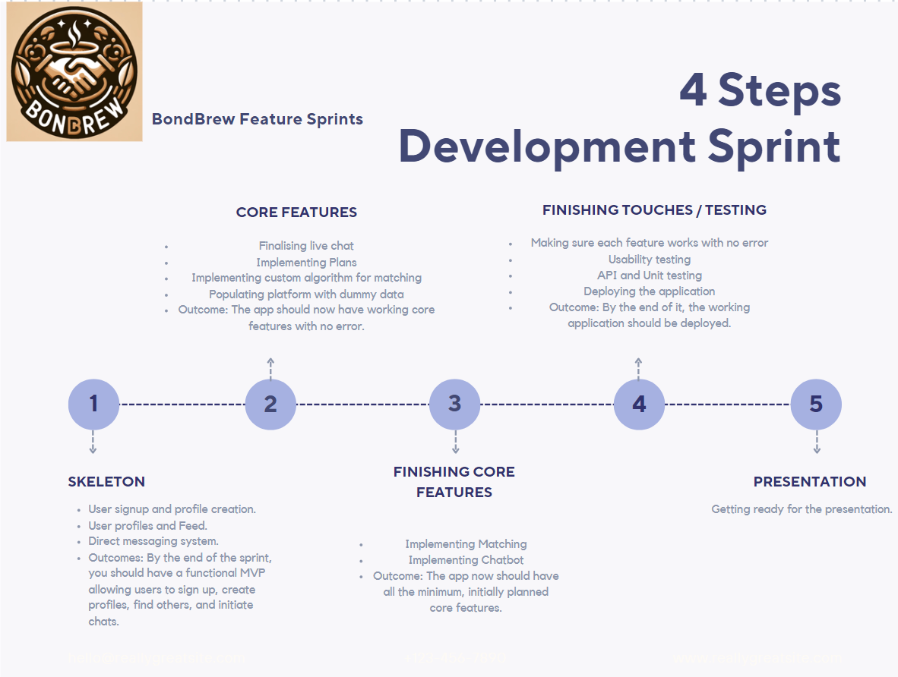

**(Figure 1: Four sprints of the development. )**

Due to the extensive scope of the project, it was divided into smaller, manageable chunks, each with a clear goal. The project was organized into four sprints, with four main milestones, as illustrated in the diagram below.

4. Design & implementation

The embodiment of the project called BondBrew, the platform, employs an innovative approach by incorporating four main features that set it apart. Although these features are not entirely novel and are present in niche applications, the unique integration of modified versions of these features collectively distinguishes the platform. Figure 2 represents the custom-designed logo of the platform.

  
(Figure 2: The logo of the project.)

## 4.1 Development

In the book Continuous Delivery by Humble and Farley (2011), numerous guidelines are advocated as industry standards, including modularization. This approach entails not only breaking down the code but also organizing directories into sub-folders for each component. A prime example of this is the component folder on the client side, where code components are extensively reused thanks to this method. From Chapter 6 onwards, the book highlights the principle of separation of concerns, advocating for the organization of different aspects of the application into their respective folders. This approach has been meticulously applied throughout the artefact, with notable examples including the segregation of controllers, models, reducers, and actions in both the frontend and backend architectures. This organizational method enhances the maintainability and scalability of the application. Building on this foundation of structured and efficient software practices, the integration of Docker further supports this philosophy by simplifying and streamlining the deployment process.

## 4.2 Architecture

The application adopts a Containerized Microservices architecture to ensure portability, scalability, and maintainability. The entire project is containerized using Docker, comprising four containers in the local environment and six in the deployed version. The main component architecture relies on these four containers, as illustrated in Figure 3, which also shows the data flow among them.

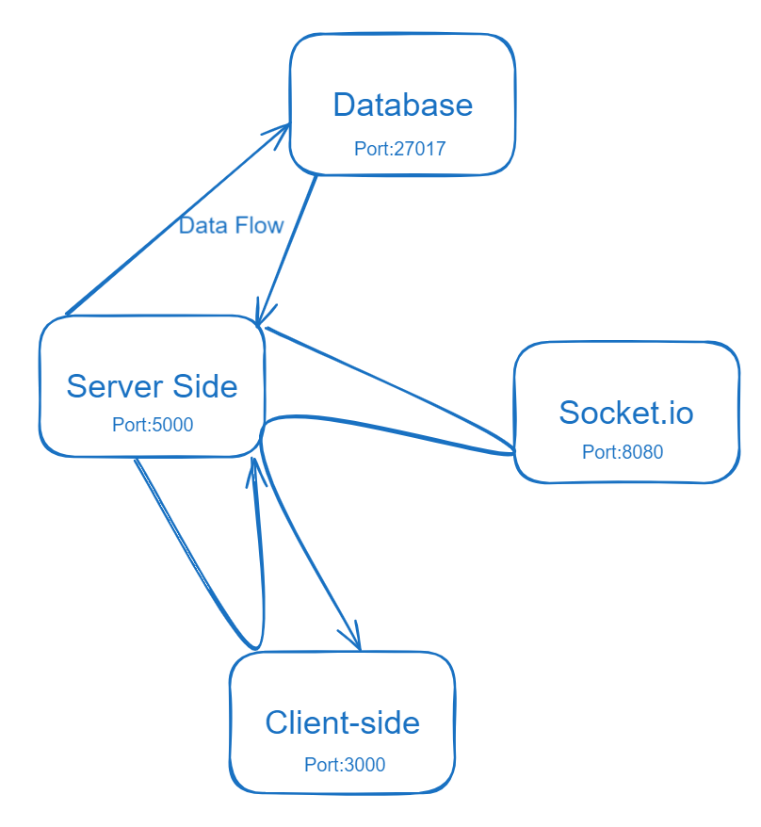

(Figure 3: The main four containers)

## 4.3 Server Side

The server side is implemented using Node.js with the Express framework. It follows the Model-View-Controller (MVC) pattern, excluding the views since it involves server code only. Example on Figure 4.

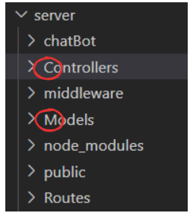

(Figure 4: Snippet of server code directory)

Each client request is independent and contains all necessary information, allowing the server to operate without maintaining any session state between requests. The server hosts resource-oriented REST APIs, each with a unique Uniform Resource Identifier (URI). These resources can be created, retrieved, updated, or deleted (CRUD) using standard HTTP methods (GET, POST, PUT, DELETE). This decoupled approach enables the independent development and deployment of different components, enhancing flexibility in the programming languages used across the systems, as communication between components occurs via JSON (Omar et al. 2019).

The server also manages all uploaded static files, such as images, locally rather than using a third party or storing them in a database to simplify the architecture. This approach minimizes costs and computational demands, making it suitable for the prototype since all data used is freely available. Furthermore, the design allows for easy scalability, changing storage strategies would require updating just a single line of code in the .env file as Figure 5 shows.



(Figure 5: Snippet of the images route)

## 4.4 Database

The database of choice was MongoDB, selected for its suitability in handling semi-structured or unstructured data, which is often characteristic of social media data (P. Mhapasekar Darshan, 2017). As the project progressed, the volume and type of data requiring storage increased linearly. Utilizing Mongoose, schemas were implemented that emulated the behaviour of a relational database, providing the added benefits of ease of use and flexibility.

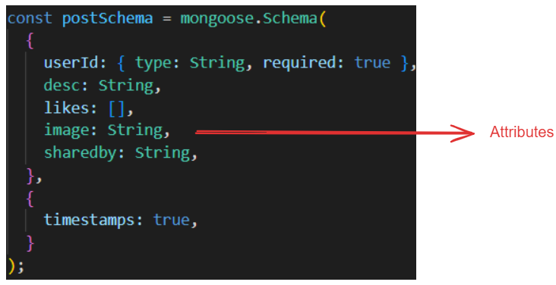

(Figure 6: Snippet of a Model)

This allowed for simple adjustments rather than extensive redesigns of the database requirements, thereby accelerating the development timeline.

To adhere to best practices and prevent confusion, the database was systematically structured. The structure of the database is illustrated by Figure 7, which demonstrates the logical organization and relationships between different data entities.

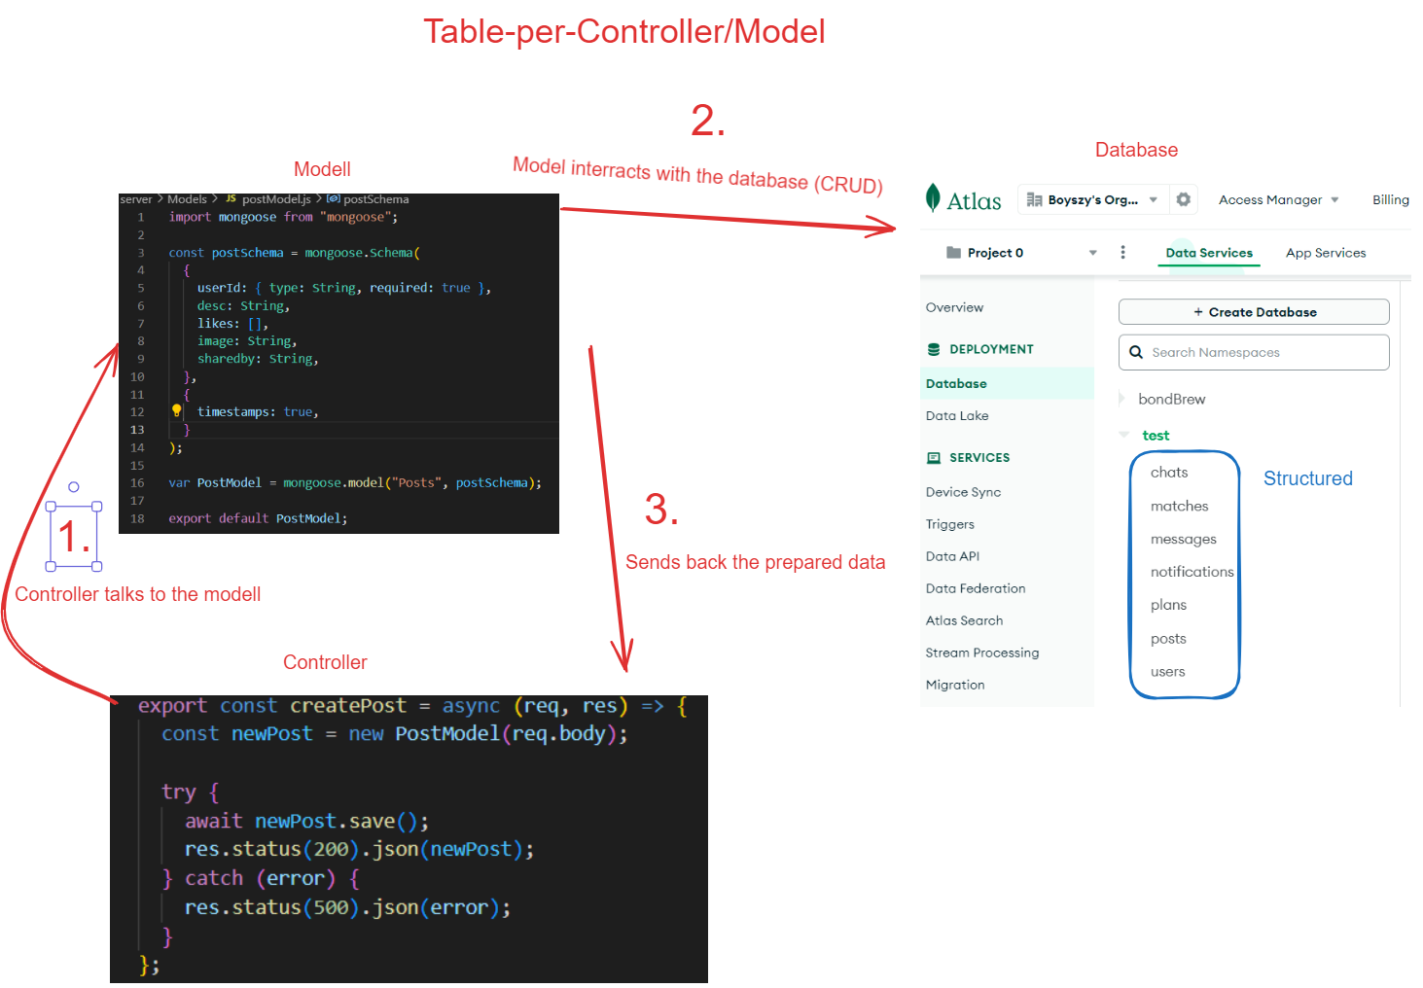

(Figure 7: Diagram of the how unstructured became structured)

## 4.5 Client-side

React is utilized for creating dynamic user interfaces, while Redux is employed for comprehensive state management. React's component-based approach promotes code reusability, which is particularly well-suited for developing complex and dynamic social media user interfaces, as noted by Gao and Han (2012). Redux is utilized for managing data access across multiple pages, such as user information and state stages, including button states or complex data loading processes. This approach ensures that the content, including buttons and larger loads such as posts, is dynamically updated, offering a more professional appearance by avoiding the impression of a frozen site.

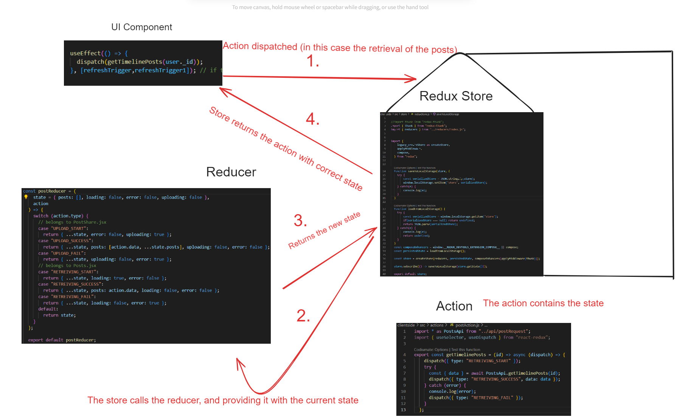

(Figure 8: Diagram explaining redux)

In scenarios of slow internet or when loading a large number of posts, the website displays a straightforward message: "Posts are loading," instead of appearing to freeze. As the project evolved and more components loaded increasing amounts of data, challenges became apparent, particularly in environments with slower internet or limited computational resources, such as a virtual machine. Initially, when users logged in under these conditions, no data appeared on the website; only the UI elements were visible because the Redux store had to load everything. This issue was resolved by adopting a new approach to data retrieval using the fetch method.

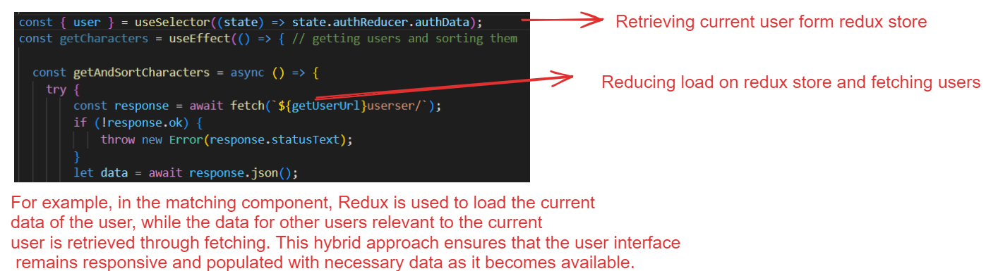

(Figure 9: Snippet of fetch and redux function used simultaneously)

The strategy involved initiating an initial data fetch when a component mounts, providing an effective method for displaying data while the rest of the application loads. This approach proved particularly useful on pages where the data was exclusive to that page, such as in the matching and plans components (Fariz et al. 2022).

## 4.6 WebSocket

The system was designed to facilitate bi-directional communication between the client and the server. This architectural choice was primarily driven by the goal of performance optimization. Socket.io is utilized to maintain long-lived connections, which are crucial for handling high volumes of small messages effectively. By directing WebSocket traffic to a separate server, the system can enhance both network and resource performance significantly (Appelqvist and Örnmyr, 2009).

## 4.7 containerization

Each container in the system is provisioned with its own Dockerfile, which specifies the creation of a container with an environment specifically tailored to its needs. Figure 10 is an example of a docker file.

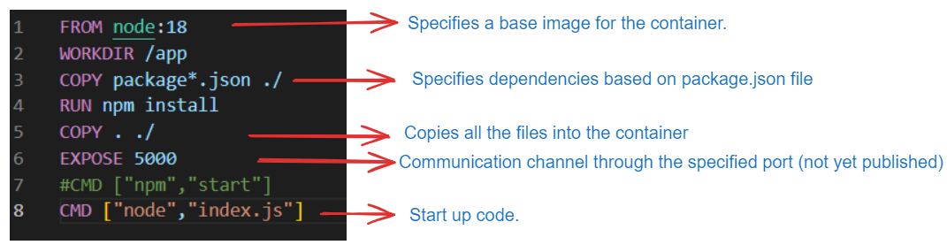

(Figure 10: Snippet of a docker file)

In this setup, a Node environment is configured within a Node container. After the environment is set up and all necessary dependencies are installed, the server is initiated on a dedicated port to facilitate communication.

To orchestrate the initiation of all containers and execute the described steps in sequence, a Docker Compose file is employed. This configuration simplifies the startup of the entire program to a single command line, initiating all containers, publishing their ports, and mounting a volume that allows communication not only with the database but also between containers.

Upon deployment, NGINX was used as a reverse proxy and installed on the virtual machine online. It was configured to work with Certbot to ensure HTTPS is enabled. For effective operation in a deployed environment, it was necessary to replace the IP address in the NGINX.config file with the appropriate domain name.

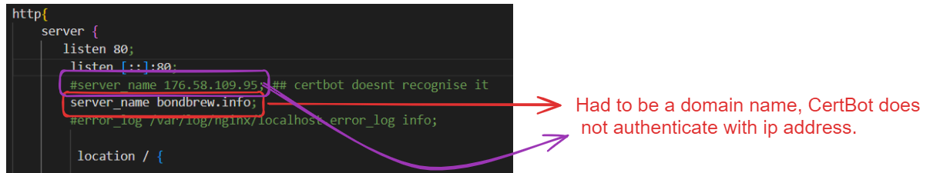

(Figure 11: Snippet of NGINX settings)

The necessity for using a proper domain name in the NGINX.config file arises because Let’s Encrypt, via the HTTP-01 challenge, uses HTTP requests to access a specific file on the domain to validate domain ownership. To meet this requirement and enable HTTPS certification, a domain name was purchased and configured.

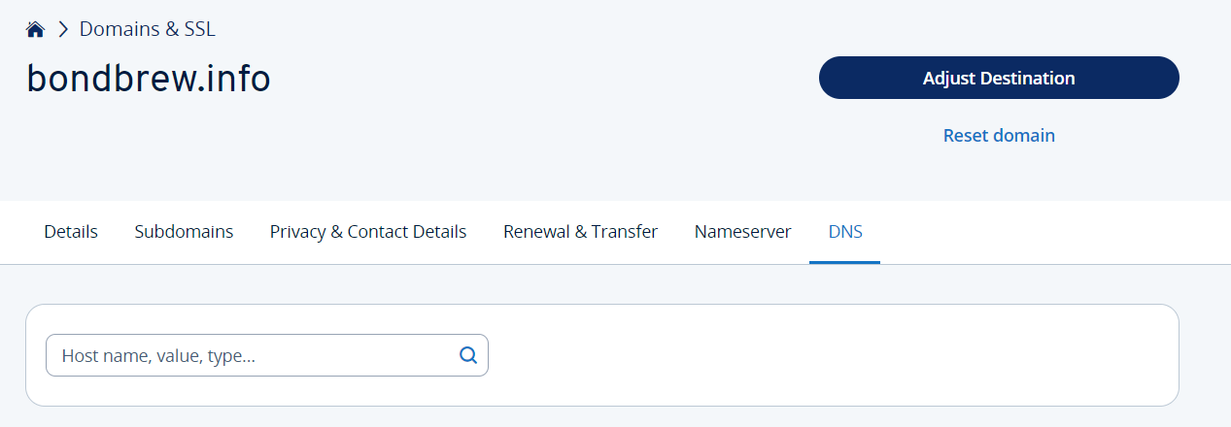

(Figure 12: Snippet of domain)

A significant hurdle was encountered with the ACME (Automated Certificate Management Environment) protocol used by Certbot. This protocol operates through the HTTP-01 challenge, wherein Certbot creates a temporary file in the web server's document root to validate domain ownership. The initial attempt to validate the first key was unsuccessful, presenting a challenge in the certification process.

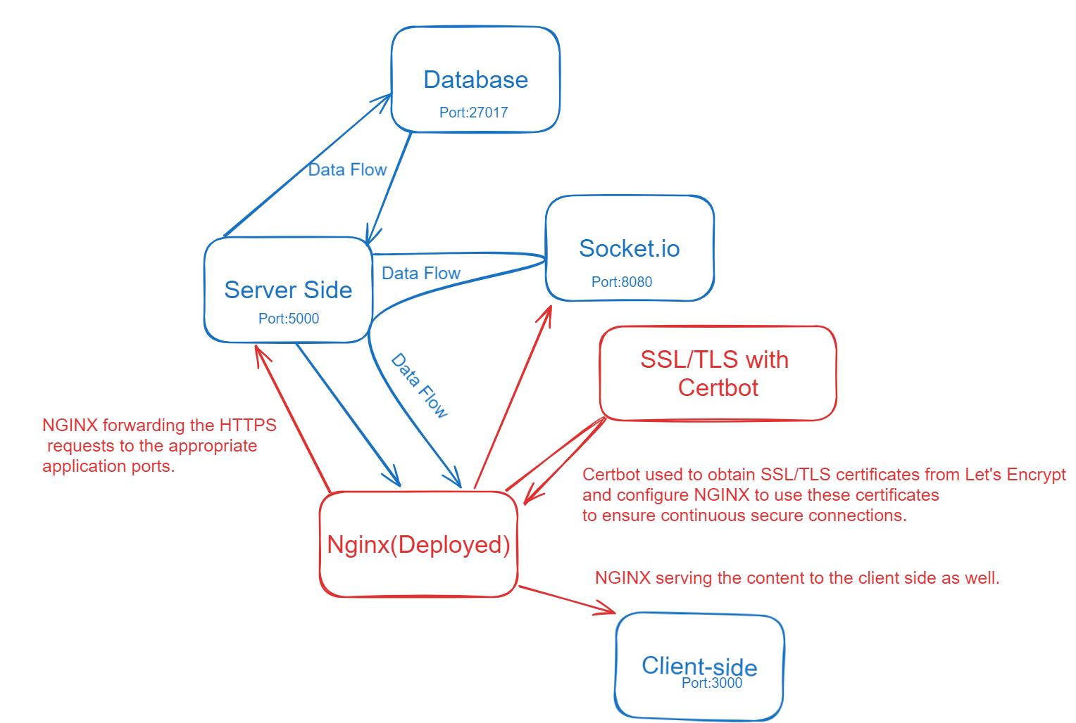

(Figure 13: Diagram of the deployed version’s containers of the project)

A partial resolution was reached by containerizing NGINX along with Certbot, and manually inserting the first key of the automation inside the root folder. This interim solution enables the deployed platform to serve static content, although it cannot currently write content, specifically images. Additionally, there is an unresolved issue with domain configuration, meaning the project is currently accessible only by its IP address and lacks HTTPS encryption, as a domain has not yet been fully established. Consequently, NGINX continues to operate under these limited conditions.

## 4.8 Home page

Like most social media applications, the data is user-specific and requires an account to access. Users have the option to sign in or sign up and they are directed to the home or landing page.

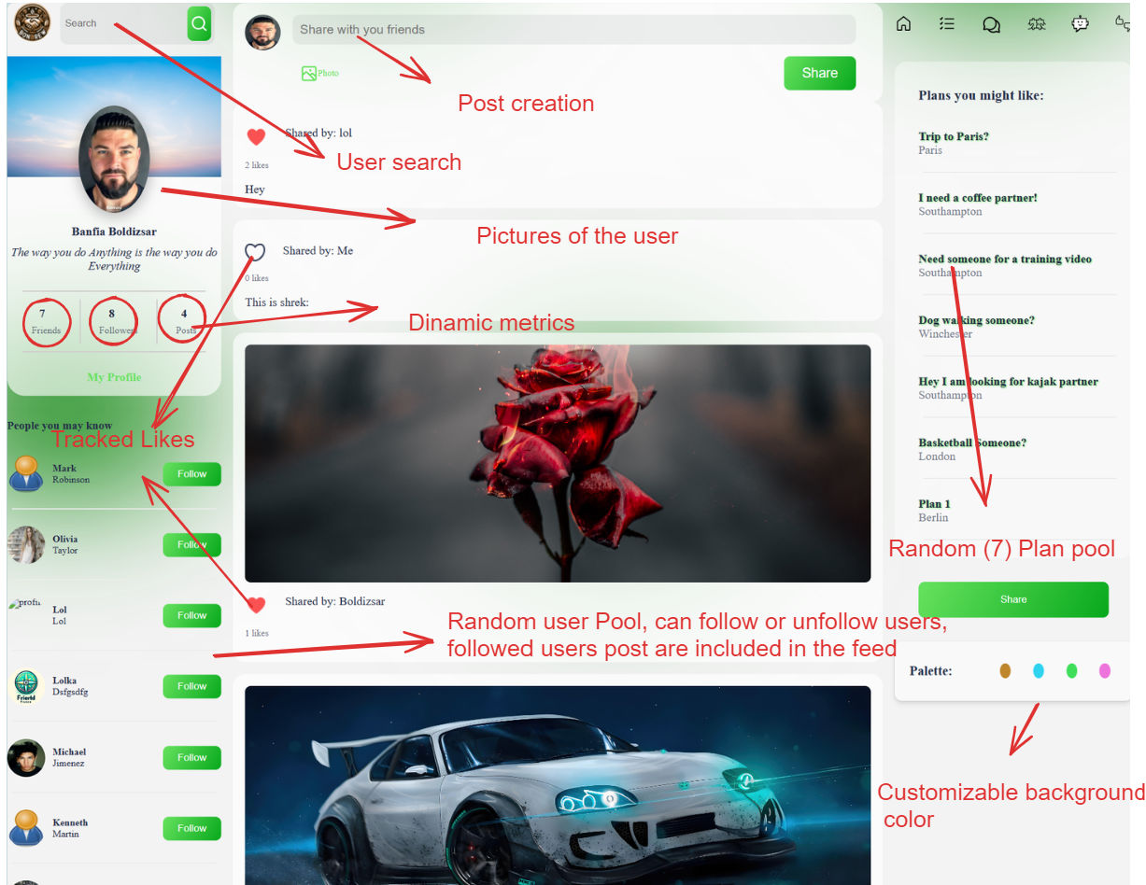

(Figure 14: Snippet of the home page)

The website features dynamic content, eliminating the need for page refreshes to see updates. This ensures a seamless user experience where changes are reflected immediately. For example, when a user follows or unfollows someone, the feed automatically updates to reflect the new content without requiring a page refresh. Even if the page is refreshed, the appearance and functionality remain consistent; nothing is lost or altered.

In terms of the layout, CSS was the sole technology used for styling, without the aid of other technologies such as templating engines. All styling files are organized and included in the directory corresponding to their respective components, ensuring that each component maintains its stylistic independence and ease of management, as illustrated in the accompanying picture.

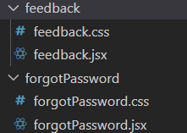(Figure 15: Snippet of file structure)

The responsiveness of the website was manually coded to ensure it adapts to different device screens. While this feature was achieved to an extent, full implementation was not completed due to time constraints. This limited implementation resulted in some responsiveness features not being fully optimized across all devices.

Additionally, there was an issue where the background colours reverted to default settings with each page refresh. To address this challenge, the chosen colour is now saved in a cookie and retrieved by the root component whenever the page is loaded. This solution ensures that the background colour persists across refreshes, maintaining a consistent user experience even after navigating away from the page or reloading it.

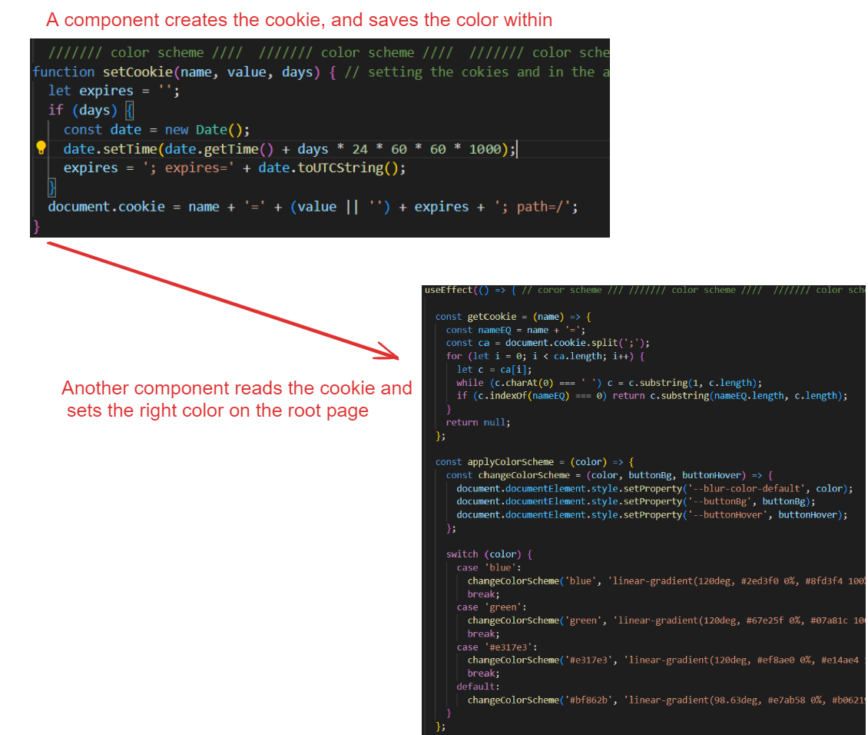

(Figure 16: Diagram of the cookie implementation)

From the home page, users can easily navigate to their user page. On this page, the feed dynamically updates to display only their posts, allowing users to focus exclusively on their content. Additionally, the user page provides options for updating personal information as well as uploading new pictures and posts.

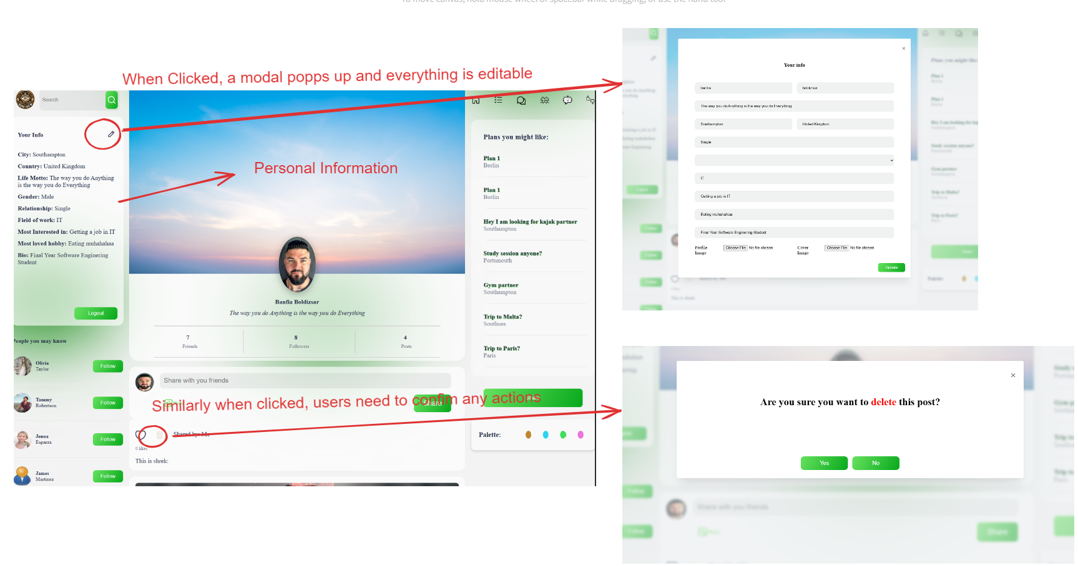

(Figure 17: Snippet of current user’s profile)

## 4.9 Plans

This function is very similar to one found on Bumble BFF, except for the map feature.

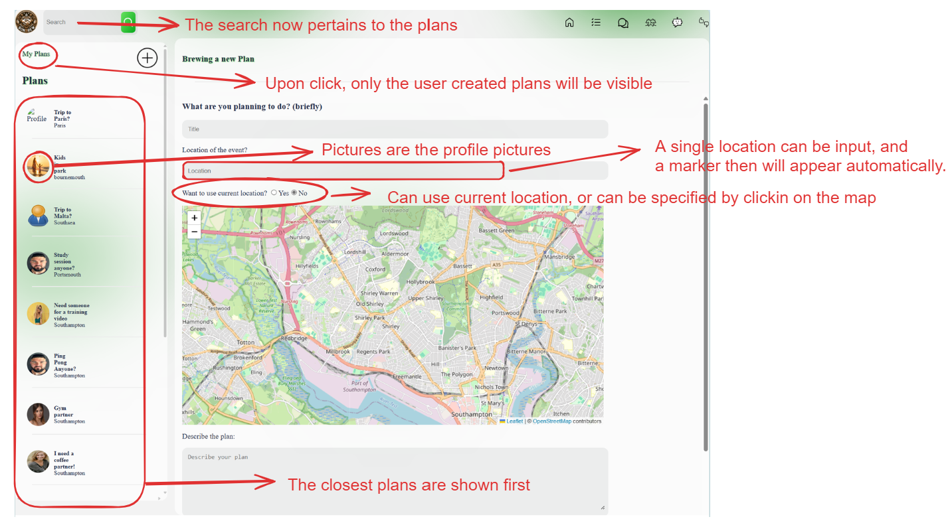

(Figure 18: Snippet of plans page)

Upon landing on the page, the location of the user is retrieved using React's geolocation and saved. This location data is then utilized by the Haversine formula to calculate the distance to various plans, organizing them into a list from closest to farthest.

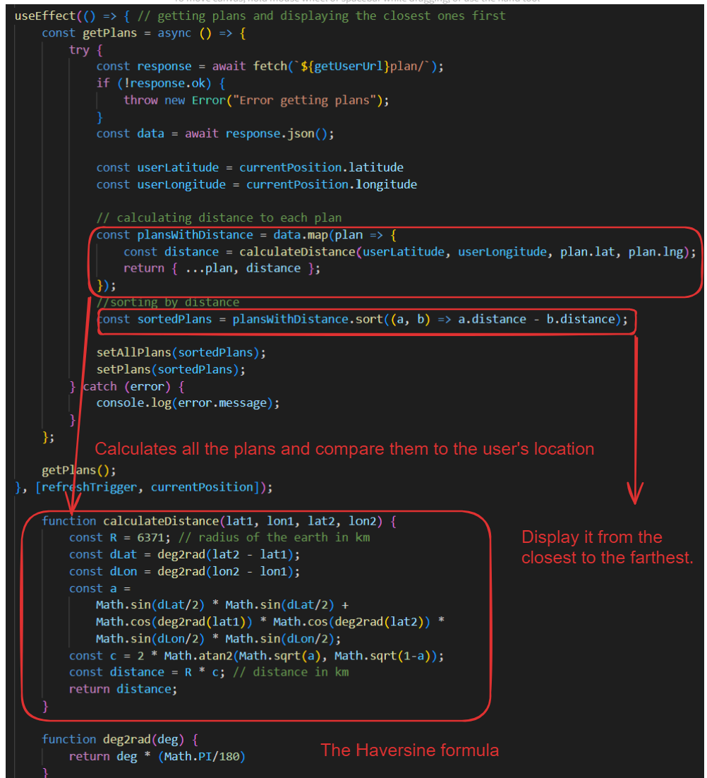

(Figure 19: Code snippet of the Haversine formula)

Users have multiple options for expressing their location when describing activities. They can:

1. Toggle their current location: This automatically places a marker at their precise current location.
2. Manually place a marker by clicking on the map: This allows for direct interaction and selection of location on the map.
3. Enter a location via text input: Users can type a specific address or location, which is then geocoded.

However, initial discrepancies between the text-entered location and the marker's placement were observed. To resolve this issue, the OpenStreetMap API is now used to retrieve the latitude and longitude of the entered location. This ensures that the map marker accurately reflects the correct position, aligning the visual marker with the specified geographical data.

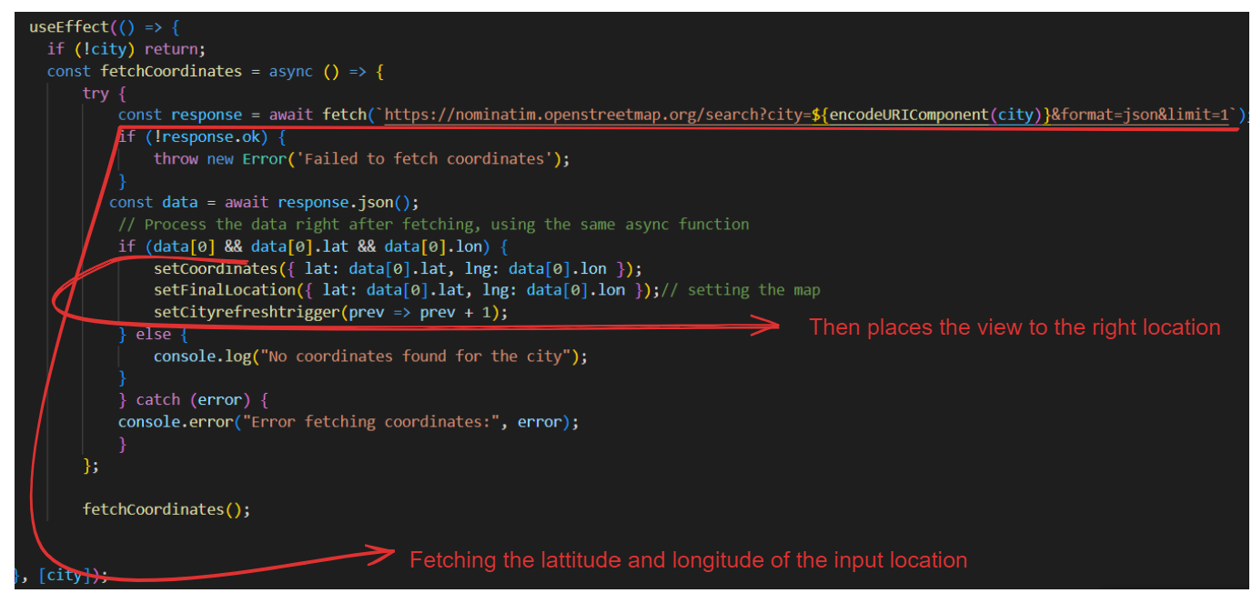

(Figure 20: Code snippet of city conversion to geolocation)

## 4.10 Chat

The chat functionality allows users to communicate effortlessly by sending messages in a straightforward manner.

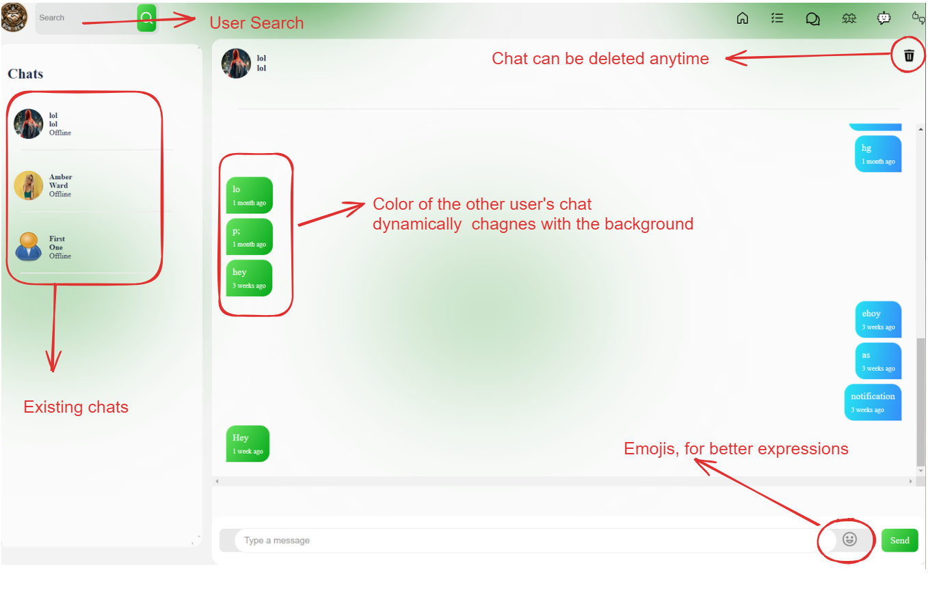

(Figure 21: Snippet of the chat page)

Real-time data transfer is facilitated by Socket.io, which creates individual web sockets for each user. This setup is detailed in Figure 22.

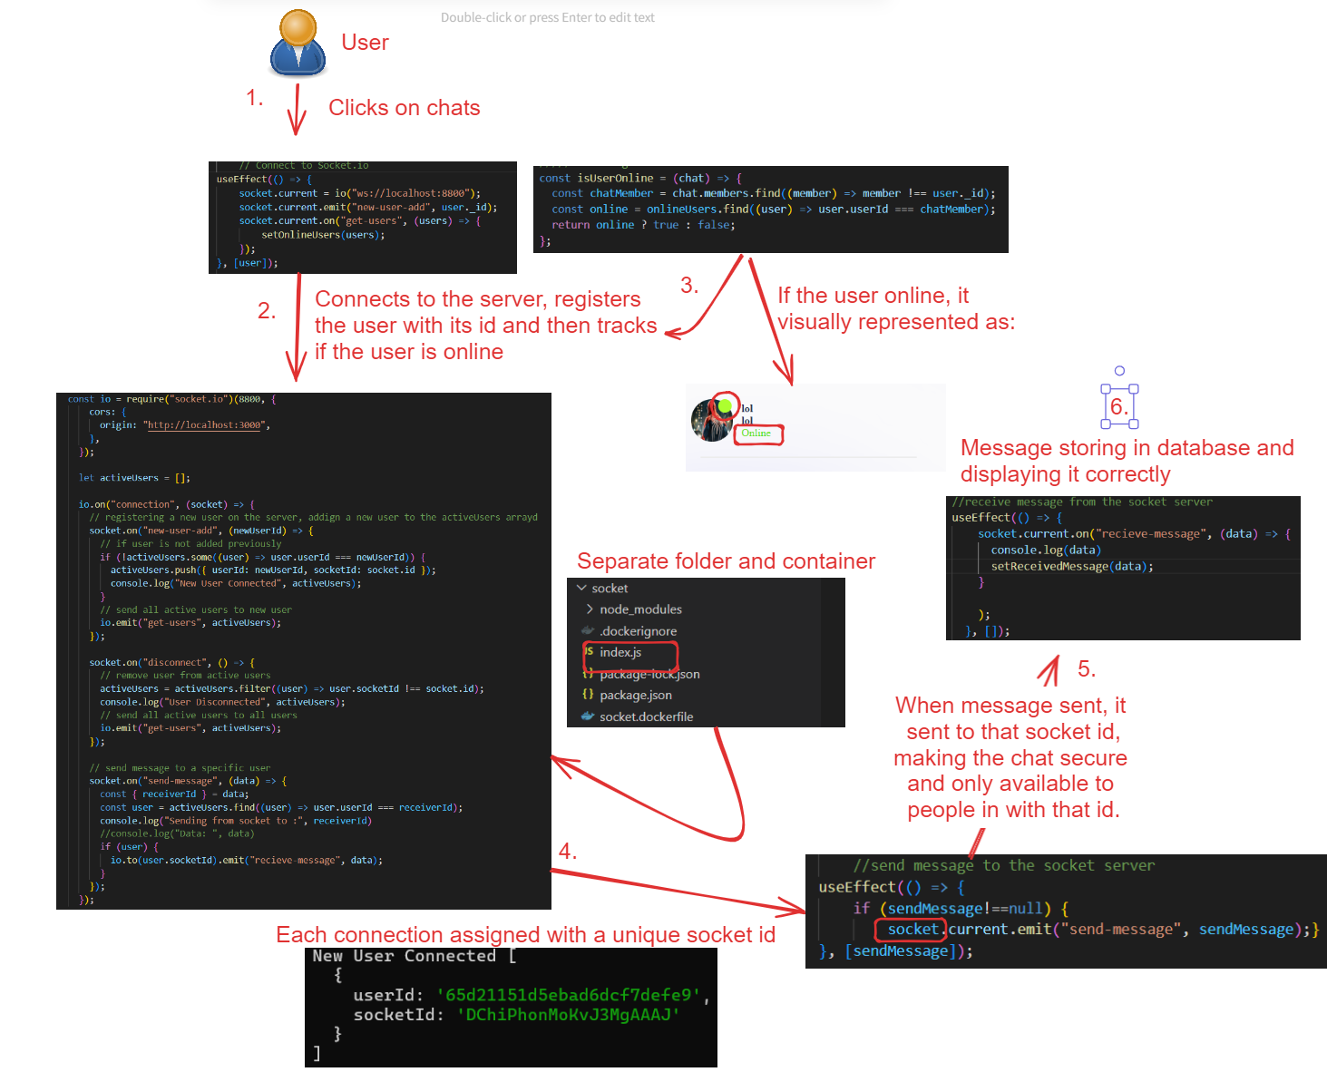

(Figure 22: Diagram of Socket io implementation)

Initially, the REST APIs and the socket server shared the same port and handled significant data volumes simultaneously. This configuration led to issues, if one component crashed or froze, it could cause the other to fail as well. Additionally, there was a message delay experienced due to the event loop being blocked. Node.js utilizes a single-threaded event loop to manage I/O operations, which allows non-blocking tasks like network calls or database queries to proceed without halting the thread, unlike traditional synchronous models (Iyer 2013; Vilhelmsson 2021). Blocking the event loop reduces the efficiency of message handling over time, resulting in delays. To address these issues effectively and enhance the overall stability and performance of the system, a strategic decision was made to isolate the socket server from the REST APIs.

Separating the socket server from the REST APIs is crucial as it prevents a single point of failure that can arise from multiple services sharing the same port and process. For example, a malfunction in the REST API could compromise the WebSocket service, leading to broader system downtime (Apostolopoulos et al. 2020). The front-end design similarly adheres to the principle of separation of concerns, which simplifies deployment and allows for future enhancements, such as incorporating group chat functionalities as planned.

The notification system operates through server-side code and is designed to be compatible with any front-end platform, as depicted in the image below.

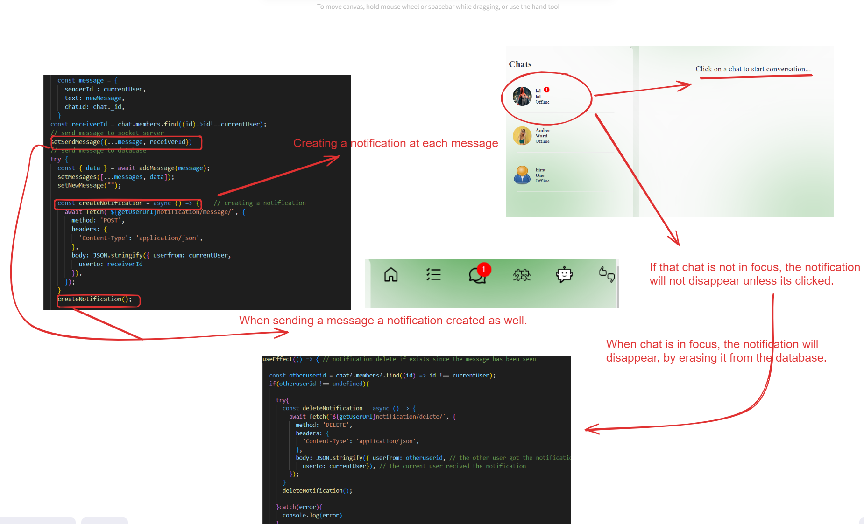

(Figure 23: Diagram of notification logic)

## 4.11 Matching

Before the process can begin, two indispensable elements are required: the location of the user and their interests. If either of these elements is not previously recorded in the database, a modal responsible for collecting this information will persistently remain open upon the first-page load, rendering the page non-functional. This design ensures that essential data is captured to tailor the user experience effectively.

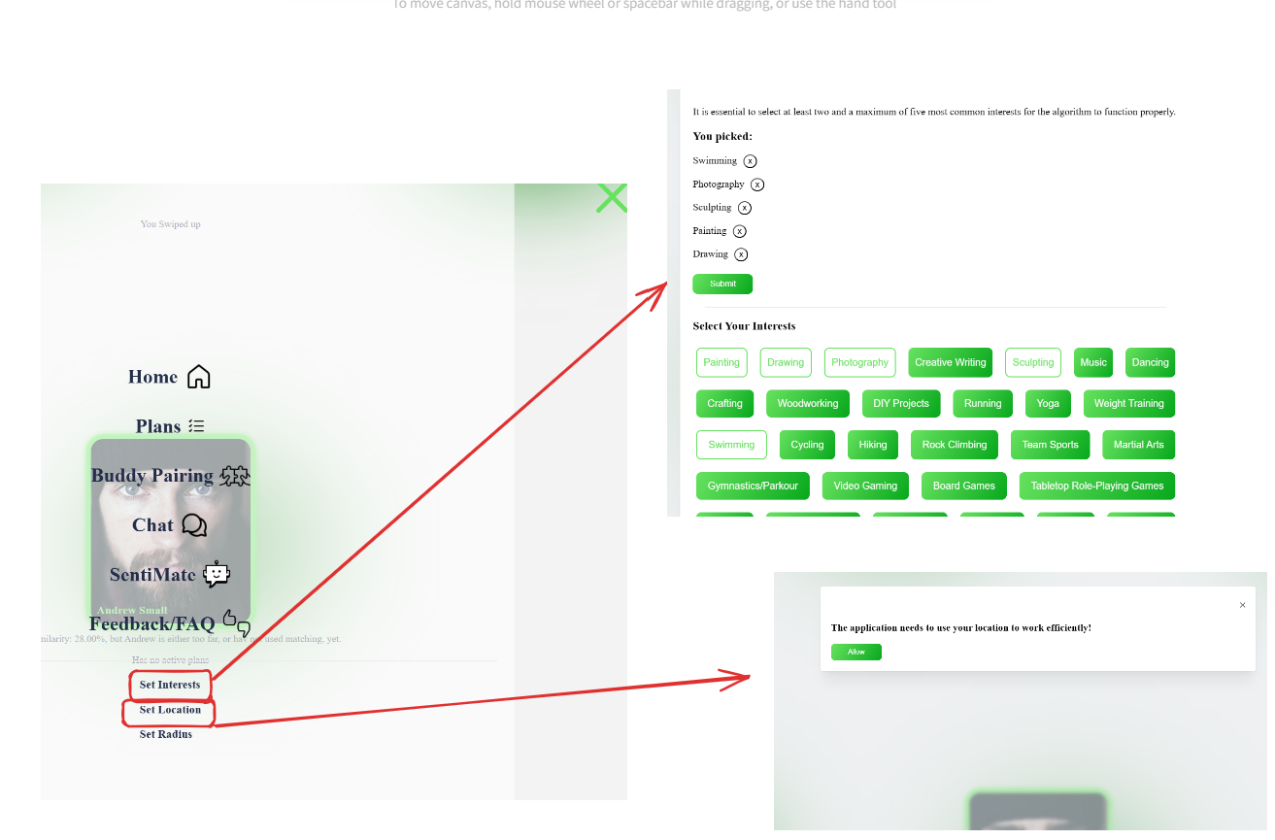

(Figure 24: Snippet of interest and location modal)

By default, when the page is opened, the process of retrieving users begins and includes multiple filters. Initially, the process retrieves users in a manner that excludes those who have already been matched with, liked, or disliked by the current user. This ensures that users only see new potential matches each time they visit the page. The logic for filtering users is handled by the controller in the server, which reduces processing steps on the front end, thereby enhancing the efficiency and speed of the user interface.

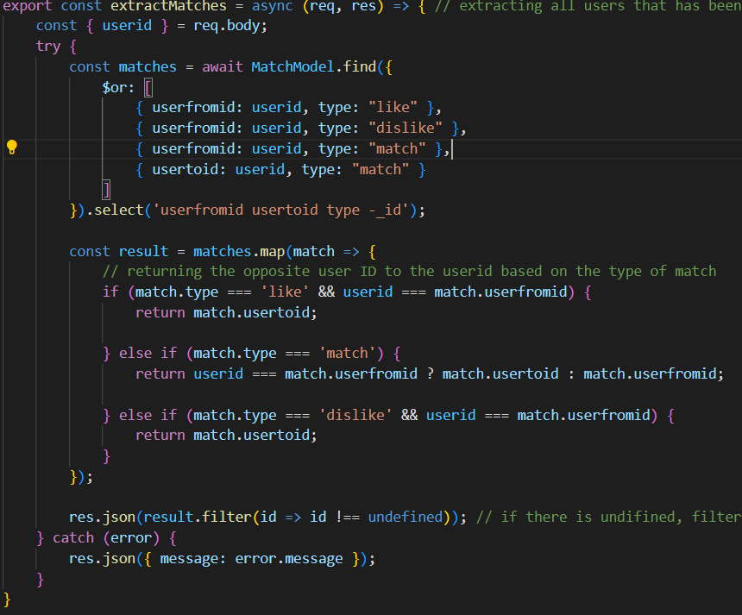

(Figure 25: Code snippet of a matching controller)

Once potential users are retrieved, each is assigned a similarity score that determines their position in the queue. The similarity score consists of two components. The first component, accounting for 30% of the total 100% similarity score, is the proximity score. This score quantifies the geographical distance between the current user and all others, translating this proximity into one part of the overall similarity metric. This calculation is achieved using a modified version of the Haversine Distance formula, where each calculated value is normalized and then scaled by 30 to determine its influence on the overall similarity score. If the distance exceeds the maximum allowable distance, the proximity score is set to zero. When the proximity score is zero, the user is deprioritized despite potentially having a higher interest score than previous users. This design reflects the principle that if a user is too far away, similarity in interests becomes less relevant due to the logistical challenges posed by the distance.

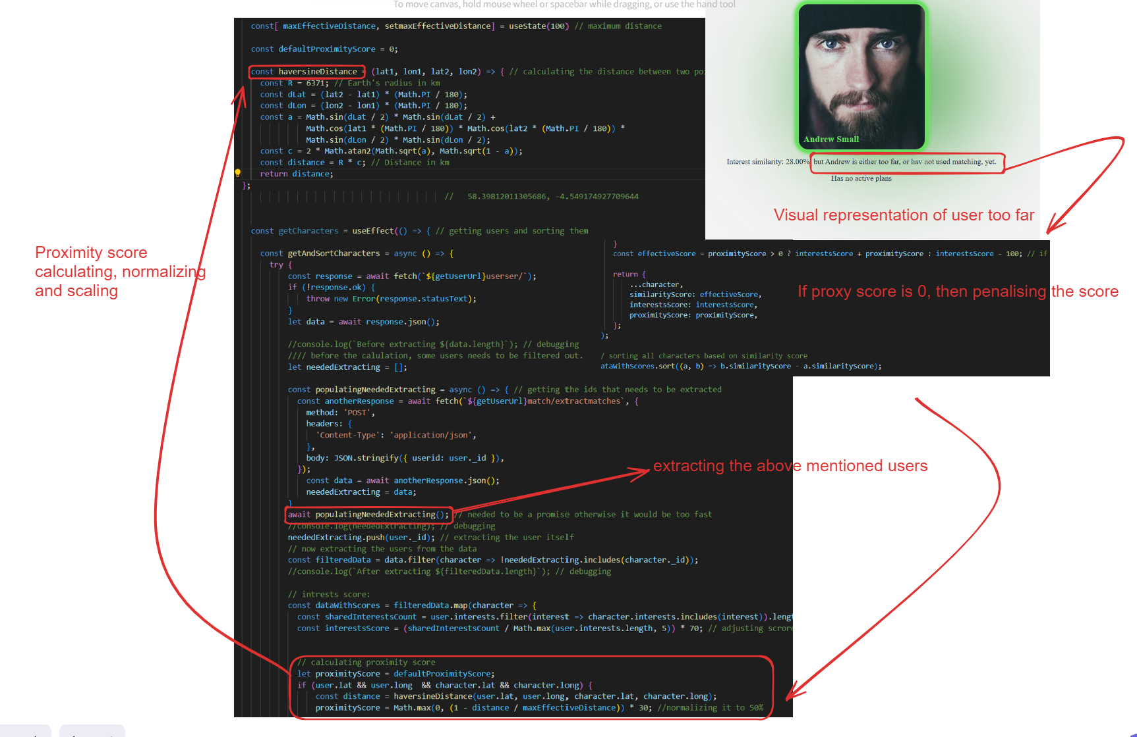

(Figure 26: Diagram of proximity logic)

Instead of choosing for the user, they can extend the distance radius, forcing the algorithm to recalculate the score. As shown in the picture.

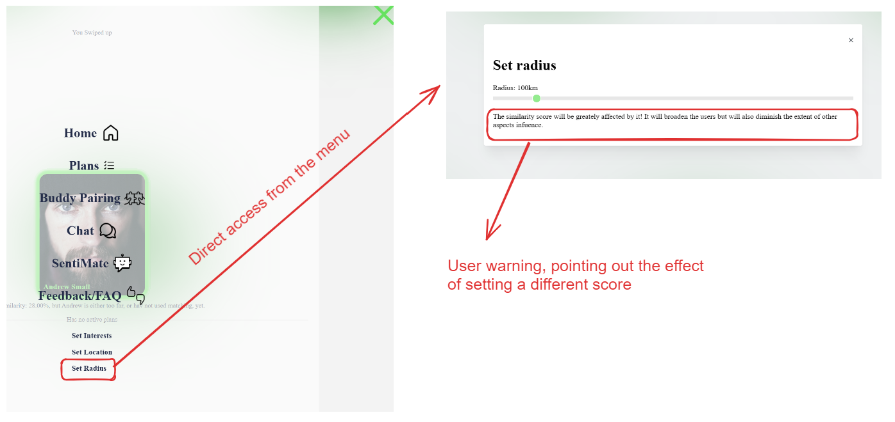

(Figure 27: Snippet of the radius modal)

The second component of the similarity score is the Interest score. This score quantifies the number of interests shared between the current user and all others, derived from the intersection of their respective interest arrays. The interest score is computed by taking the ratio of shared interests to the maximum of either the total current interests of the user or a minimum value of three. This ratio is then multiplied by 70, which accounts for 70% of the total evaluation score. This method emphasizes the significance of shared interests in the matchmaking process, influencing the likelihood of a connection.

The traditional swiping mechanism is uniquely modified to enhance user experience.

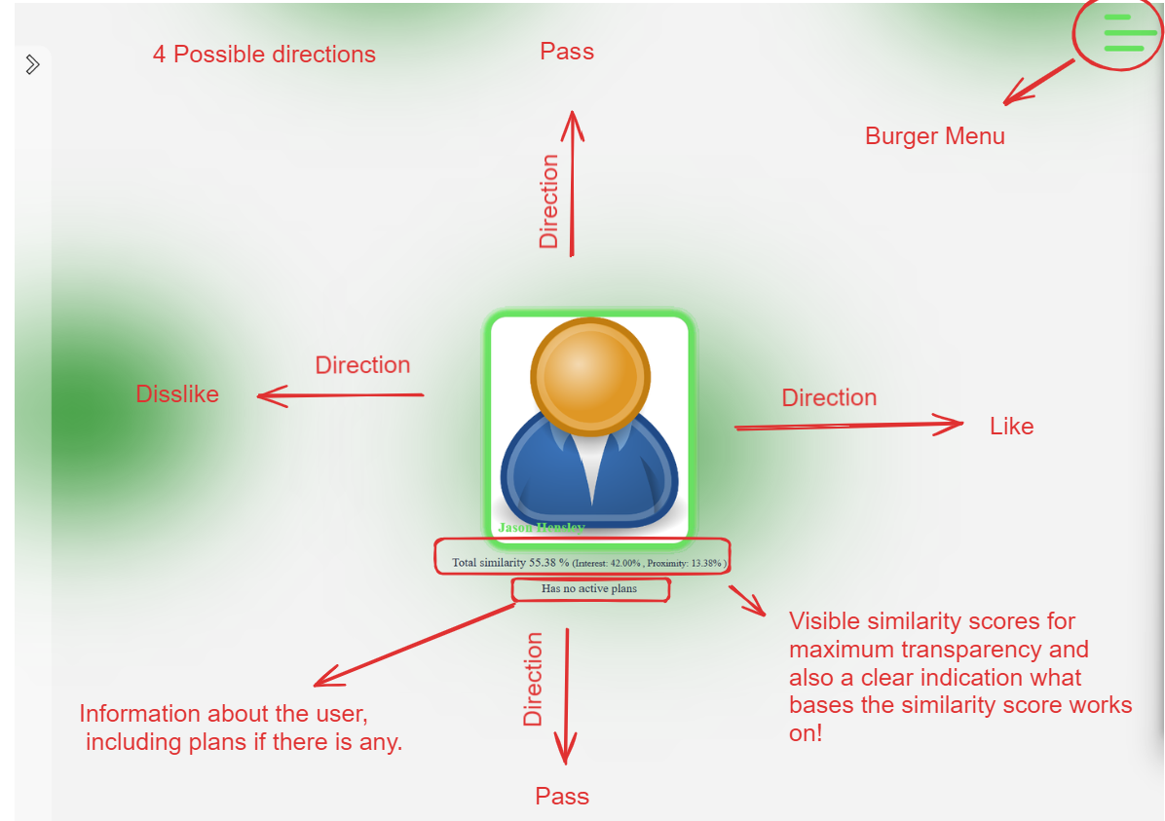

(Figure 28: Snippet of swiping logic)

As depicted in Figure 28, upon swiping up or down, users have the option to pass, thereby avoiding the need to explicitly like or dislike a person. This feature, relatively uncommon among similar applications, empowers users by providing full discretion in their interactions (Harrison et al. 2013). When a user chooses to pass on someone, that person is moved to a separate list. This list becomes visible again once there are no more new users to select from, or the passed users automatically re-enter the normal queue when the page is revisited.

Moreover, this mechanism links the plans of the user to character matching to deepen the understanding of the person, going beyond mere interest selection. This aspect aims to provide a more comprehensive view of potential matches, enhancing the connection potential based on a more holistic understanding of each user.

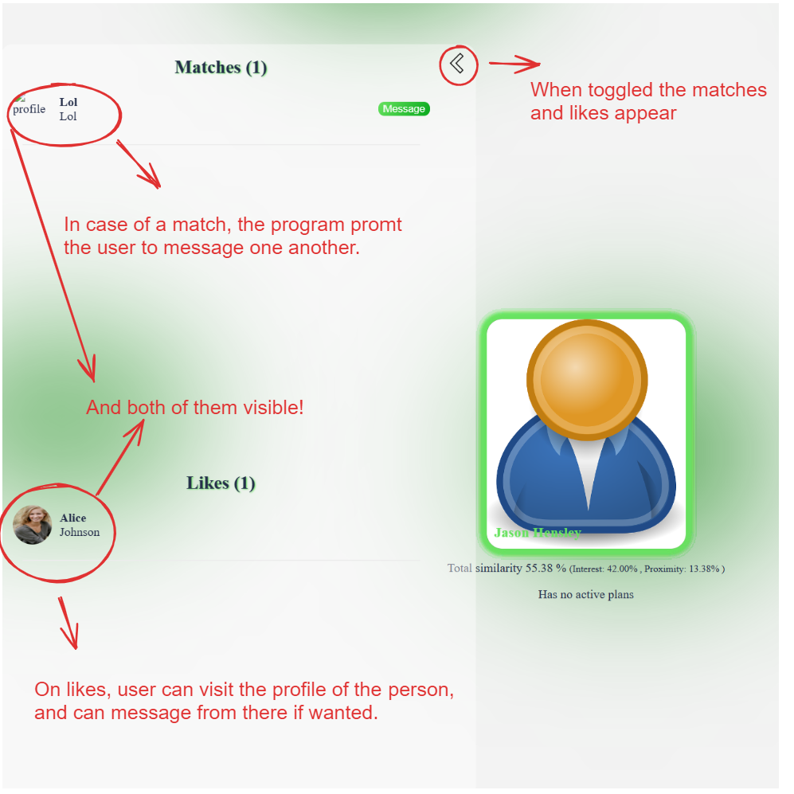

(Figure 29: Snippet of matches)

The process for liking a user is straightforward: When a user likes another person, an entry labelled as "like" is made in the database. This entry becomes visible to the person who was liked and is also placed at the front of the queue, as illustrated in the accompanying picture. If the liked person reciprocates by liking the first user back, the database entry is updated to "match." This mutual liking triggers the interaction to appear on the matches list and be removed from the likes list. This approach is designed to minimize the quantity of data stored and prevent data oversaturation by efficiently managing user interactions within the database.

This system not only simplifies the user experience by making potential connections visible and straightforward but also enhances the efficiency of data usage. By updating entries from "like" to "match," the system ensures that only relevant data is actively managed, reducing unnecessary data retention and optimizing performance.

## 4.12 Chatbot

## The most challenging aspect of the project stemmed primarily from the novelty of the technology and the limited resources available, with only the technology's documentation serving as a precise information source. The initial implementation attempt failed. Prior research suggested that Meta's LLaMA model could be an ideal fit for the project. Although the steps involved were similar to those in the current project, the outcomes differed. At the time of development, there was no publicly and freely usable version of the model, requiring local downloading and training. Given that deployment was within the project's scope, the considerable size of the model would have significantly raised costs and added complexity, not to mention the increase in response time and the lack of extensive background knowledge.

The final and current version of the project was achieved by leveraging LangChain running on JavaScript, integrated with a language model from OpenAI. The server-side architecture was designed as a RESTful API capable of serving any front end.

Continuous data vectorization initially resulted in prolonged response times, hampering system performance. To address this, the vector database Supabase was integrated, enabling the storage of pre-computed vector representations. This adjustment eliminated redundant vectorization computations, allowing the system to simply retrieve the requisite vector data from the database. Consequently, response latency was significantly reduced, enhancing overall system responsiveness.

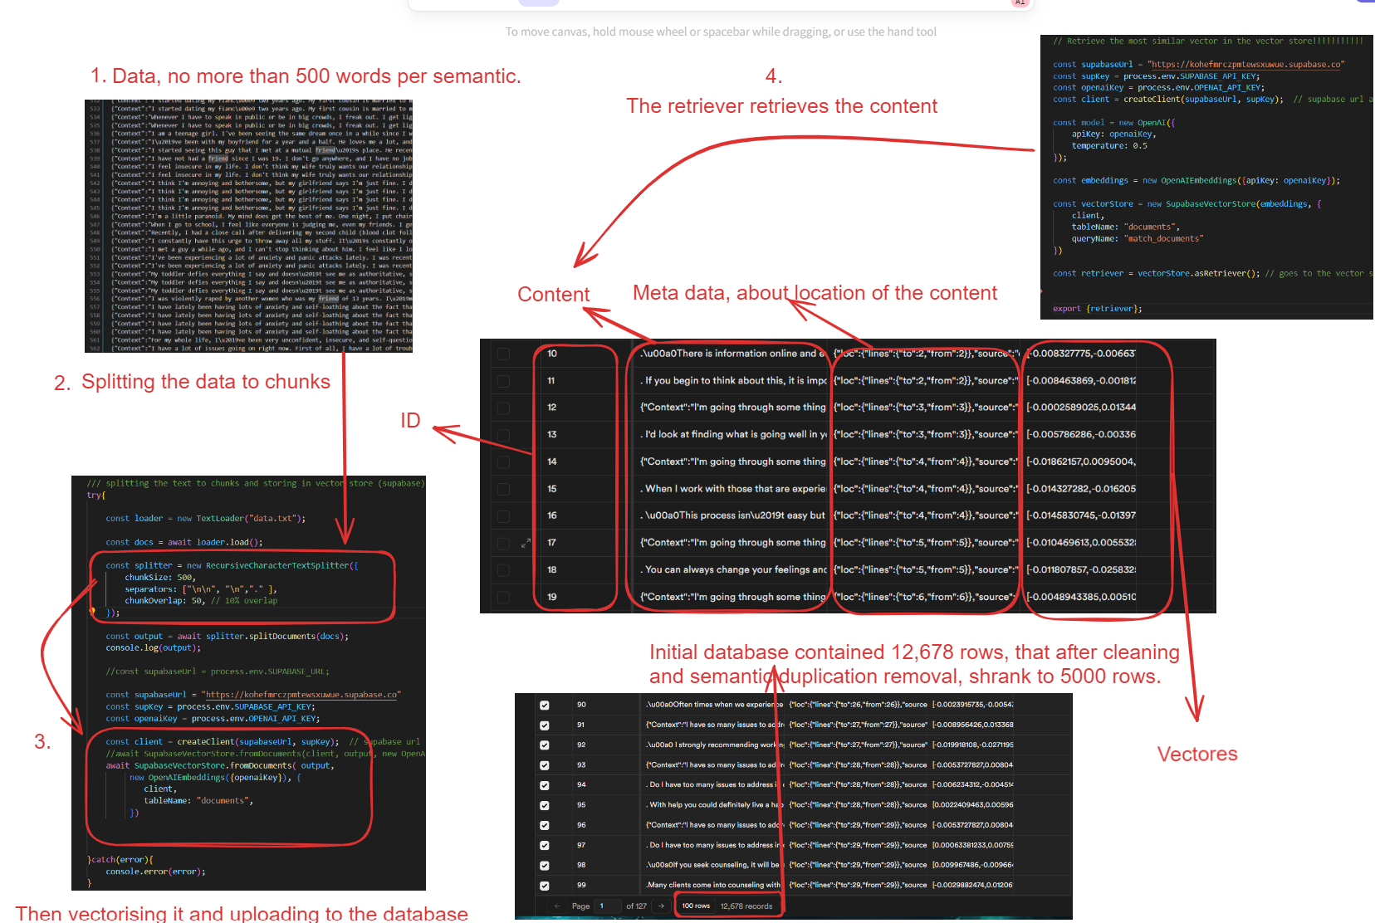

(Figure 30: Diagram of vectorization)

Figure 30 illustrates the process where data is initially segmented to ensure that no topic extends beyond 500 characters per chunk, facilitating easier retrieval. Topics are divided into semantically coherent chunks, for instance, one chunk may address suicide due to loneliness, while another explores financial reasons for suicide.

From the thousands of data rows available, the program must accurately identify the correct information to return. To refine its understanding and craft an appropriate response, the program generates a standalone question from the input of the user. This is particularly essential when utilizing a large database, as verbose or complex questions can distort the response. This standalone question is then vectorized, enabling the program to efficiently retrieve the most relevant answer from the Supabase database. This answer is subsequently refined for accuracy and relevance.

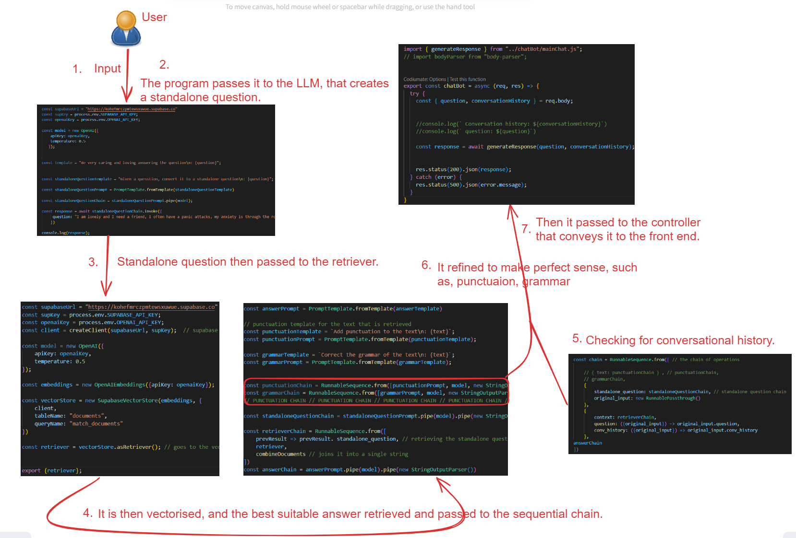

(Figure 31: Diagram of steps taken by chatbot)

After processing the query, the system prioritizes privacy by managing its memory in the client-side to ensure that no personal data is stored beyond the session. The memory of the chatbot is configured only on the front end and is designed specifically to not store any data, except for the conversational history. This history is automatically erased when the user exits the page or opts to delete it, thereby safeguarding user privacy.

## 4.13 Tests

During development, each component, including all features, underwent rigorous testing with input validation to ensure optimal functionality. Continuous tests on access control were performed to verify the integrity of role-based access controls. This ensured that users were restricted to accessing only the features and data relevant to their permissions, safeguarding the security of the application and user privacy.

The code for both the server and client sides was meticulously crafted to handle errors professionally. Rather than causing the application to crash, any encountered errors were configured to be displayed in the console. This approach helps maintain the application’s stability and provides developers with clear insights for troubleshooting without impacting the user experience.

Each API endpoint was thoroughly tested to ensure its reliability and correct functionality. The endpoints were also comprehensively documented using Swagger. This documentation provides a clear and structured overview of all API interactions, facilitating easier maintenance and scalability of the application by offering developers and users a guide to how the APIs function.

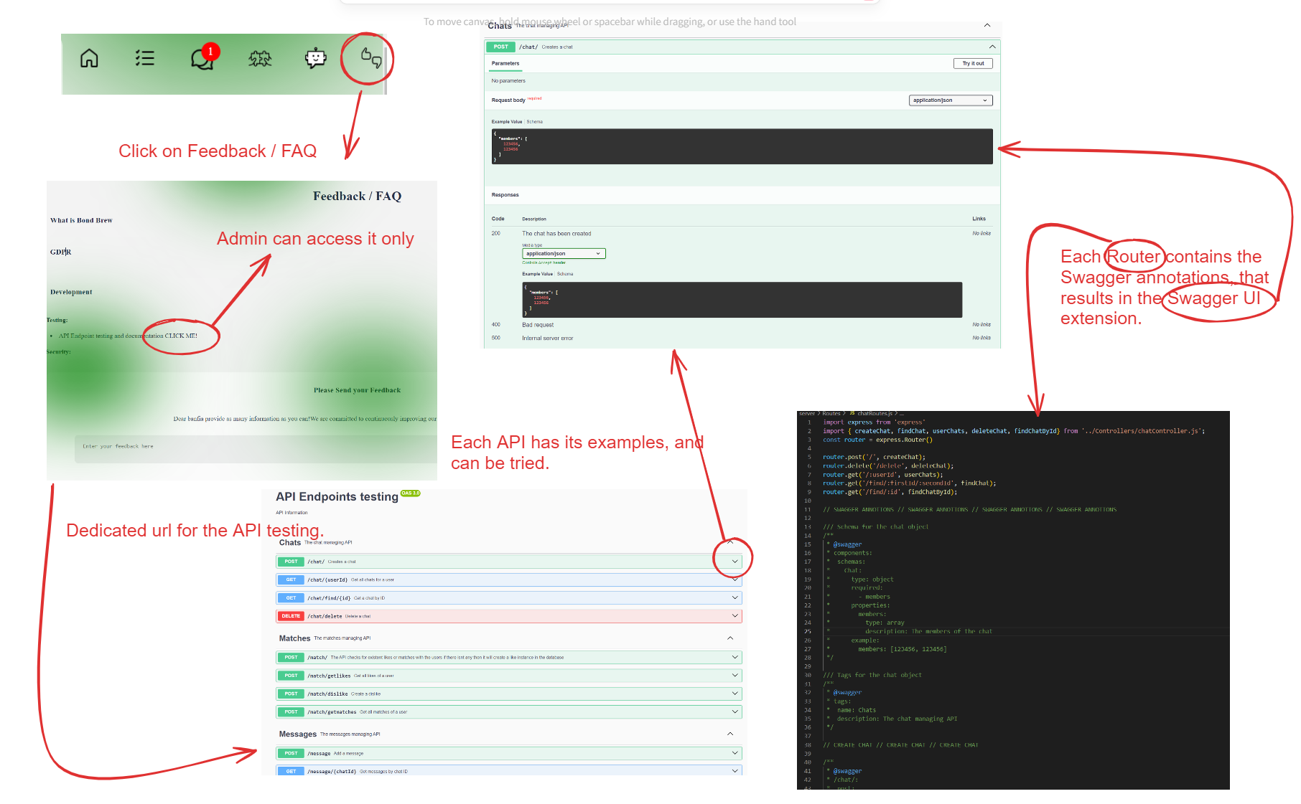

(Figure 32: Diagram of Swagger logic)

As illustrated in Figure 32, Swagger UI was incorporated to enhance the development interface of the application. This tool provides a detailed description of the API attributes and their values, enabling a thorough understanding of each endpoint's function. Administrators have the capability to test these endpoints directly within the Swagger interface. They can use not only the provided example inputs but also custom inputs to simulate different scenarios, receiving immediate feedback on the API responses. This integration facilitates effective testing and troubleshooting.

Unit testing was initiated to ensure the reliability and robustness of individual components within the application. However, due to time constraints, this phase of testing had to be paused. While some initial tests were conducted, the full suite of planned unit tests could not be completed within the project timeline. This component of the development process remains a priority for future completion to ensure all functionalities meet the expected standards of quality and performance.

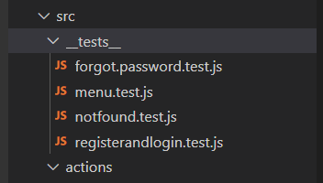 (Figure 33: Snippet of test directory)

## 4.14 Deployment

For deployment, Linode was selected due to its cost efficiency. The platform utilizes a virtual machine running on a Linux Debian distribution, chosen for its reliability and performance.

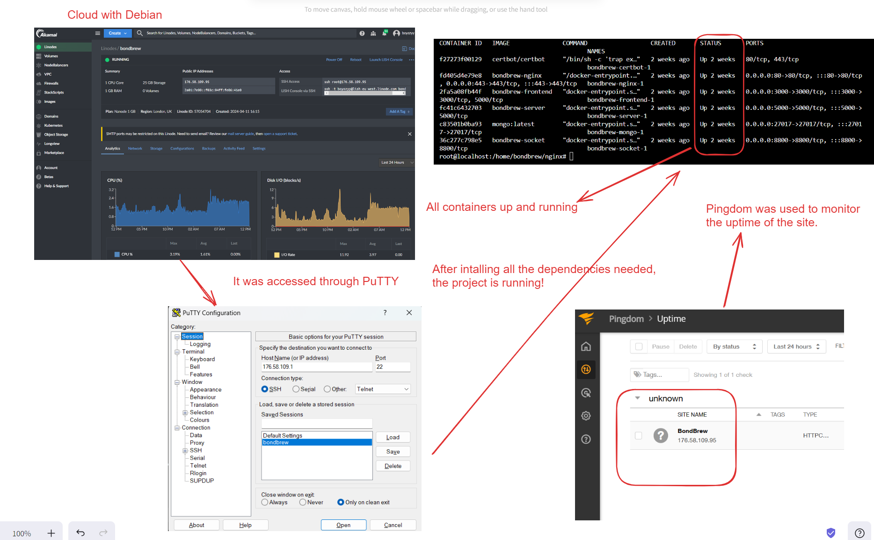

(Figure 33: Diagram of deployment)

As discussed in the containerization section, due to time constraints, the deployed version of the platform is not fully operational. Currently, it functions in a "read-only" mode. This limitation means that while users can access and view data, interaction capabilities such as adding or modifying content are not available.

## 4.15 Security

Security was a key focus during the development of the platform. The first security measure a user encounters is the stringent password requirement. As depicted in the accompanying image, specific password criteria must be met to ensure strong user authentication.

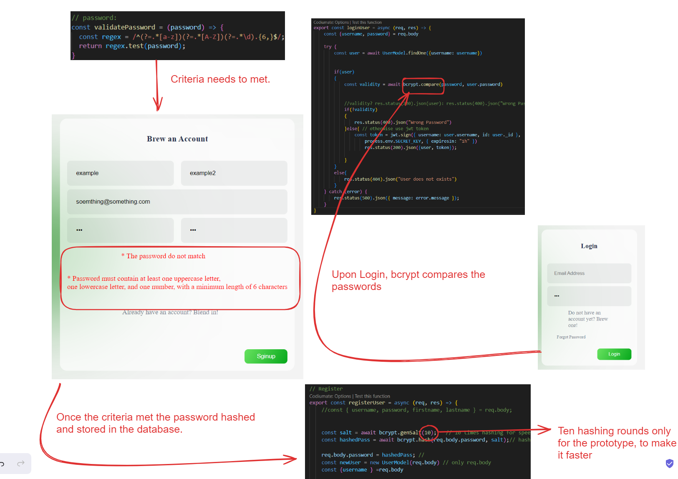

(Figure 34: Diagram of password criteria)

Passwords are securely hashed before being stored in the database, effectively preventing direct access to the original passwords. Upon login, the bcrypt hashing function is used to ensure that passwords cannot be decrypted. Bcrypt employs one-way hashing with salt to enhance security, comparing the re-hashed login attempts with the stored hash for user verification.

For further security, JSON Web Tokens (JWT) are utilized for authentication processes. This method facilitates cross-origin requests and eliminates the need to store session data for each user. The token is then used to validate every user-related action, as shown in the picture below. This approach not only secures the authentication process but also streamlines user interactions with the platform by maintaining a stateless server environment.

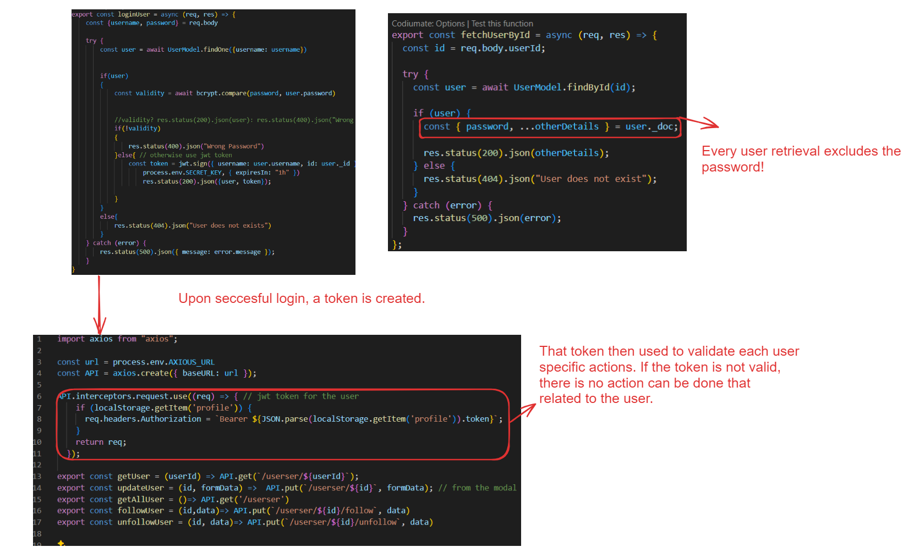

(Figure 35: Diagram of JWT logic)

In the process of retrieving user data, passwords are always excluded to enhance security, even during the initiation of a password reset. The password reset process is streamlined for user convenience and security, as illustrated in Figure 36.

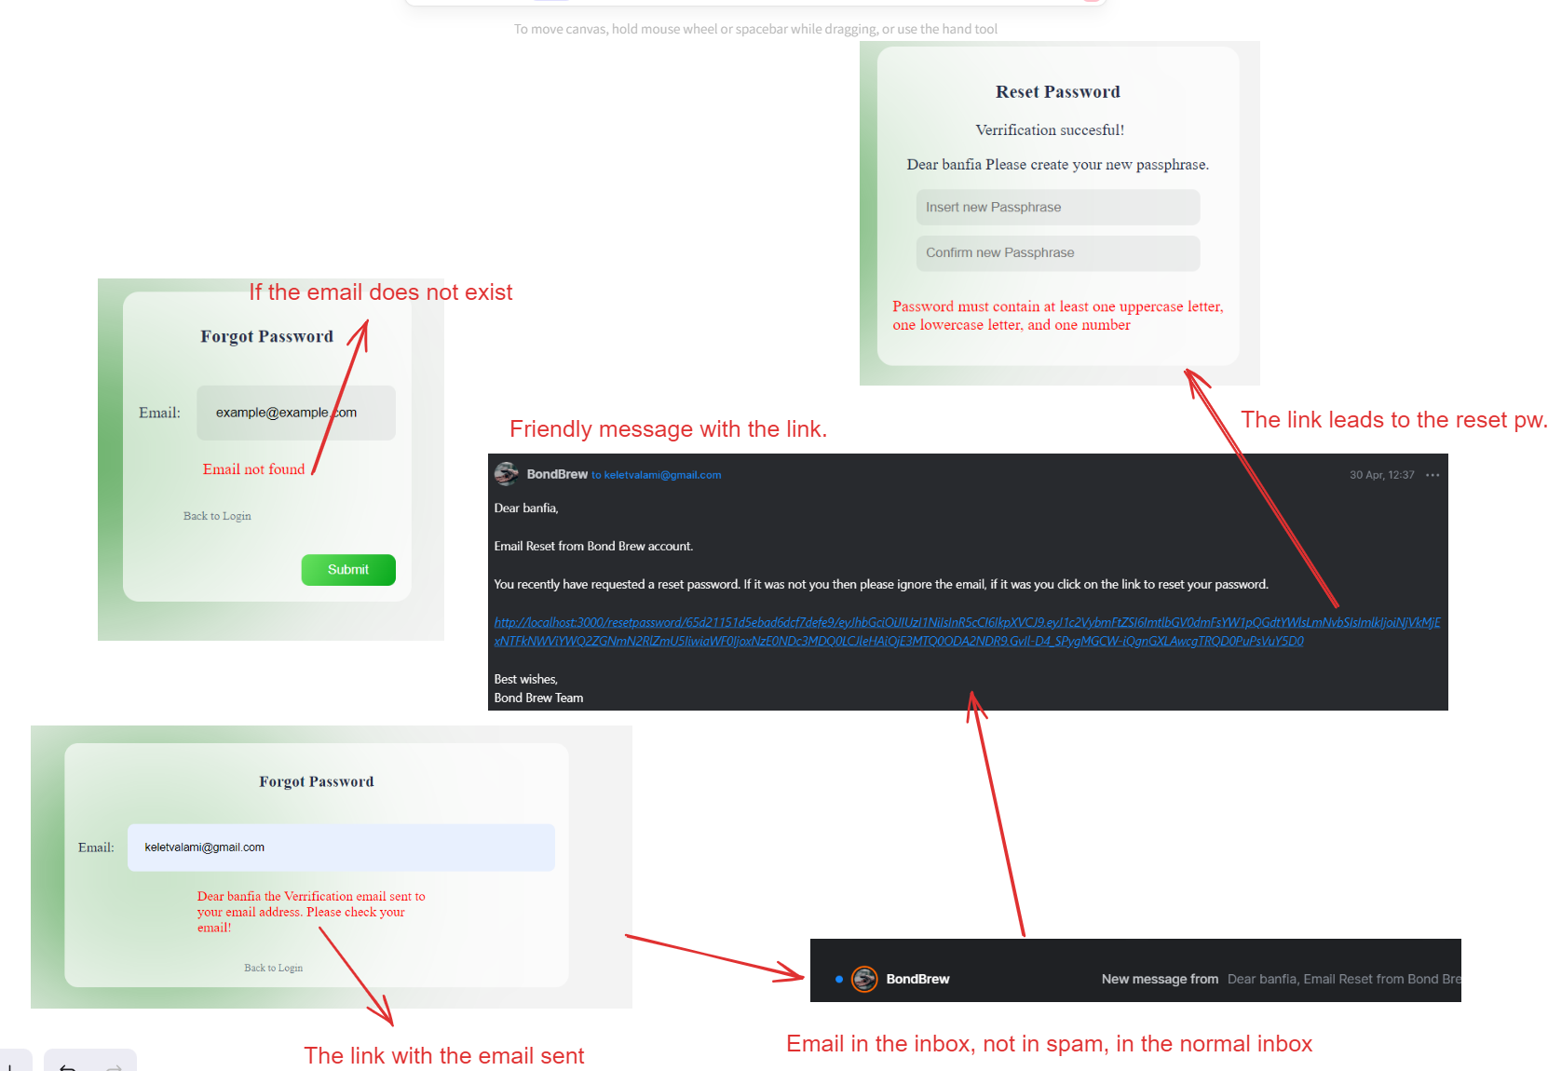

(Figure 36: Diagram of reset password logic)

When a user requests a password reset, a token is generated and sent to them via a link. This method allows users to securely change their passwords without the need for security questions, thereby reducing the risk of unauthorized access.

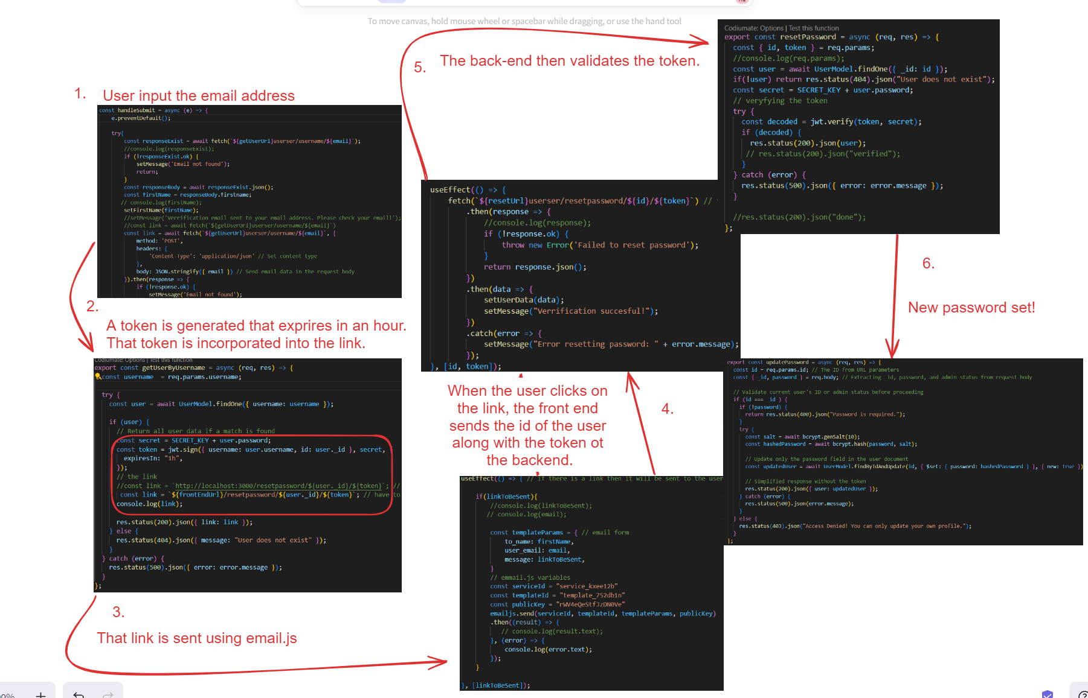

(Figure 37: Diagram of password reset in the back end)

Security consciousness was a critical consideration throughout the development, especially in the design of the chatbot. Given that therapeutic chats can involve sensitive information, it was essential to ensure that the chatbot does not store any data. Moreover, the chatbot is designed to be incapable of accessing any personal user data. This design ensures that sensitive information remains private and that users retain full control over what is shared through the application.

# 5. Results

Here you will detail all of the results you collected. You may choose to use tables or graphs to show your results.

This section summarises and provides evidence of what has been achieved and will reference additional materials in the appendices.   For projects that test a theory or concept, it will analyse the results of the investigation in relation to original expectations and draw conclusions about the theory or concept.

.

# 6. Conclusions

The primary objective of this dissertation was to explore the evolutionary roots of loneliness and its increasing prevalence in contemporary society and to design and validate a technological intervention aimed at mitigating this pervasive issue. The project successfully led to the development of BondBrew, a minimal viable product of a social media platform specifically tailored to enhance social connectivity and alleviate feelings of isolation among users.

The project demonstrated a degree of originality and creativity, particularly in how it approached the problem of loneliness. Despite the limited sample size and the speculative nature of long-term user engagement due to the platform not being released publicly, the initial results are encouraging.

The initial survey indicated that people were interested in the outlined features, which, according to the research, provided a strong basis for their implementation. After the trial of the platform, the second survey revealed that these features have real potential in helping to achieve the main goal. Moreover, the overall survey results suggest that incorporating all these features into one application has the potential to achieve the same effect. These findings indicate that the application could serve as a viable alternative to existing social media platforms, offering new avenues for users to connect meaningfully with others.

The project management aspect was handled with an emphasis on transparency and continuous improvement. The use of modern project management tools and regular updates contributed to maintaining a clear direction and focus throughout the project lifecycle. Issues encountered during the development phase, such as integration challenges with third-party APIs and scaling the platform, were systematically addressed. The incremental approach proved to be very well suited for a robust project like this. It not only helped to focus on one thing at a time but also assisted in estimating the duration required to develop a feature, thereby aiding in scoping what could and could not be done within the project timelines.

In conclusion, this dissertation not only highlighted some societal and psychological aspects of loneliness but also effectively demonstrated how technology, specifically tailored social media platforms like BondBrew, can be leveraged to combat this issue. The success of the project in creating a platform that effectively fosters real-world interactions and community building among users suggests that technological interventions can indeed serve as a powerful tool in addressing complex social challenges such as loneliness.

# 7. Recommendations

Based upon your evaluation of the process and products of the project you should make recommendations about how the project could be carried forward in the future. For example, what improvements could be made to your system or experiment if you were able to continue further work on your project?   If your project was re-scoped at the review stage to ensure it was achievable, this section is likely to discuss elements removed at that point.  If your project consisted of creating a design document for a complex system, it might discuss how your design might be implemented.

# 8. Reference list

**ARMBRECHT, J. and T.D. ANDERSSON, 2017**. Event impact. Abingdon: Routledge   
  
**BBC, 2017**. Huge Spain unity rally held in Barcelona 2017. [viewed Oct 8, 2017]. Available from: http://www.bbc.co.uk/news/world-europe-41544849   
  
**BASSOT, B., 2016.** The reflective journal. 2nd ed. London: Palgrave BECKER, L.M. and J. VAN EMDEN, 2016. Presentation skills for students. 3rd ed. London: Palgrave   
  
**WEINSTEIN, E., 2017**. Adolescents’ differential responses to social media browsing: Exploring causes and consequences for intervention. Computers in Human Behaviour, 76 (Supplement C), 396-405  
<https://doi.org/10.1016/j.chb.2017.07.038>

And so on. These should all be in alphabetical order, so they are easy for the reader to find and single line spaced

Note: A ‘**Reference List**’ is a list of citations for all sources you have referred to in the body of your dissertation.

Use the Digital Object Identifier (DOI) link for the papers and journals in your lists so your supervisor/marker can easily locate and check them:  
  
**WEINSTEIN, E., 2017**. Adolescents’ differential responses to social media browsing: Exploring causes and consequences for intervention. Computers in Human Behaviour, 76 (Supplement C), 396-405 <https://doi.org/10.1016/j.chb.2017.07.038>

# 9. Bibliography

You must include a list of references, in alphabetical order by author, at the end of your report, before the appendices. This must be in the correct [SSU Harvard referencing format.](https://portal.solent.ac.uk/library/help/factsheets/resources/referencing-harvard.pdf)   The sources listed in your references section must reflect all those cited in the text of your report.  However, don’t forget that all words and work must be your own and not direct quotes from third party sources. Use the [Digital Object Identifier (DOI)](ps://library.uic.edu/help/article/1966/what-is-a-doi-and-how-do-i-use-them-in-citations/) link for the papers and journals in this list so your supervisor/marker can easily locate and check them.

# 10. Appendices

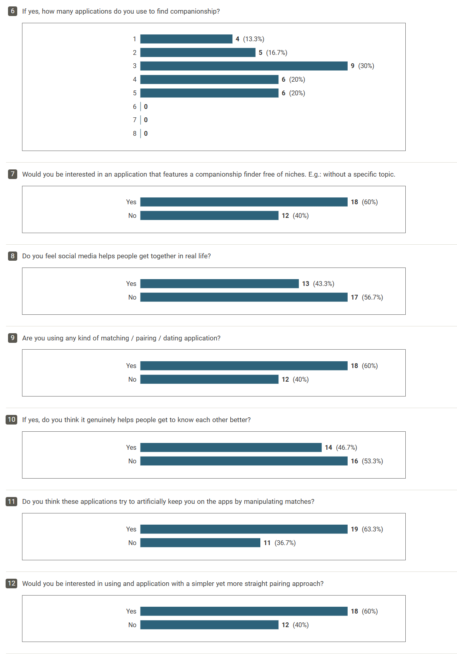  
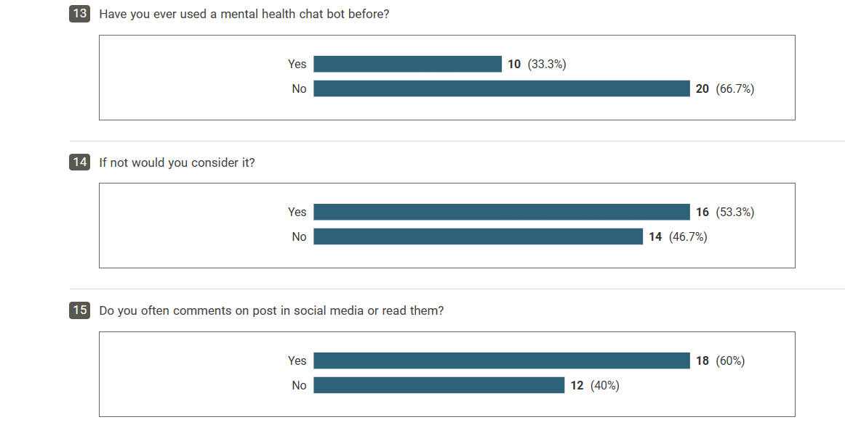

## Appendix A-2: Survey Consent form

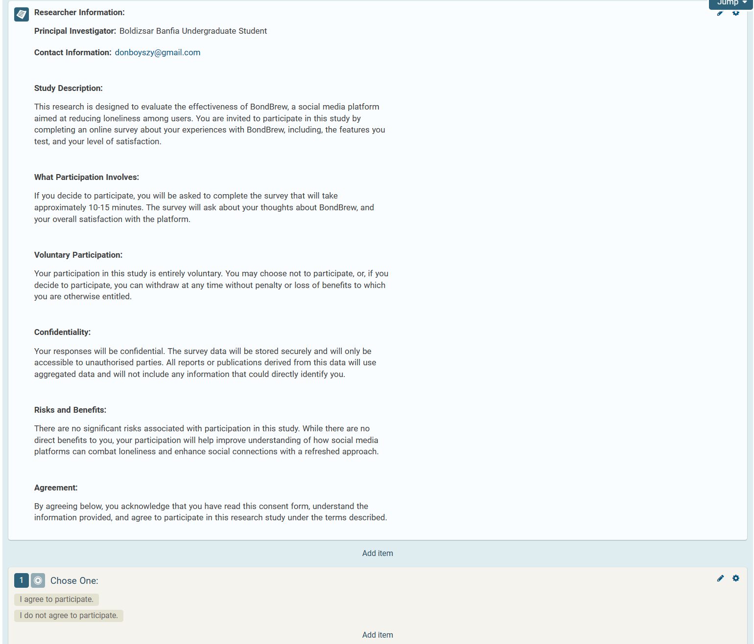

## Appendix A-3: Familiarity task before phase 3.

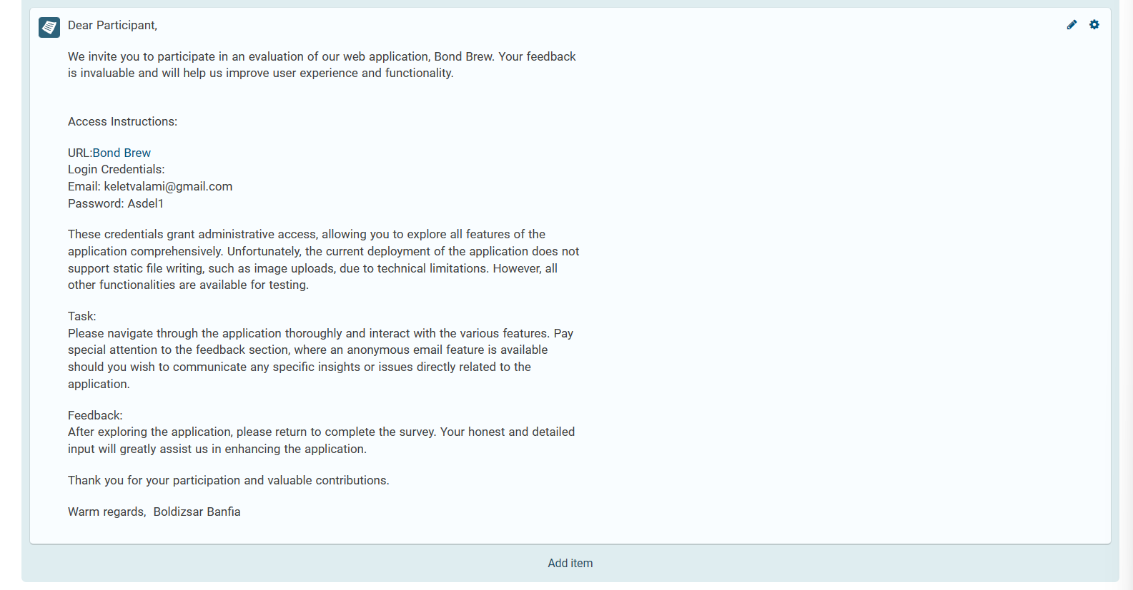

## Appendix A-4: Second Survey results:

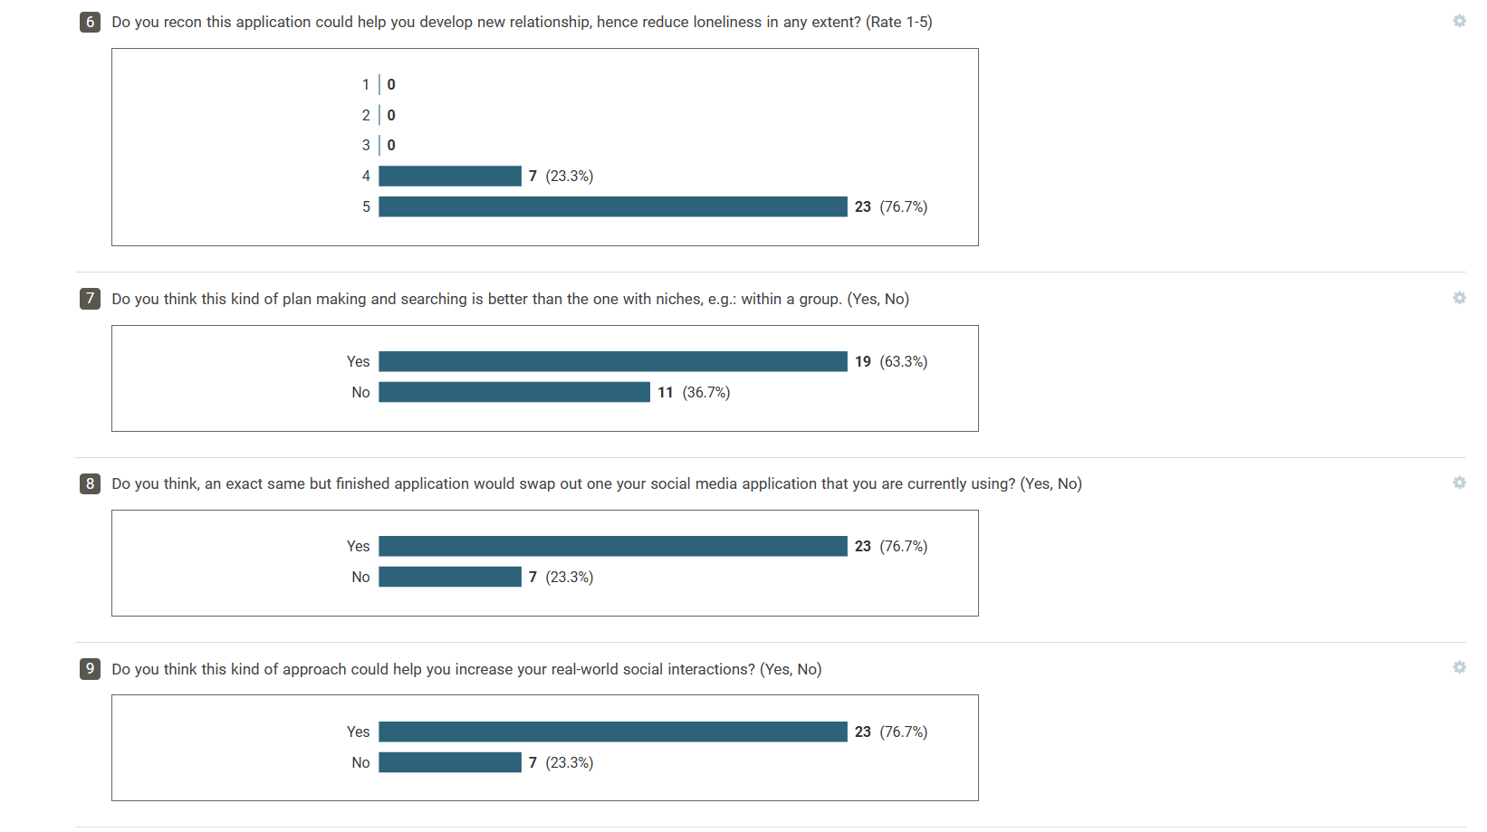

## Appendix B-1: Git commit history.

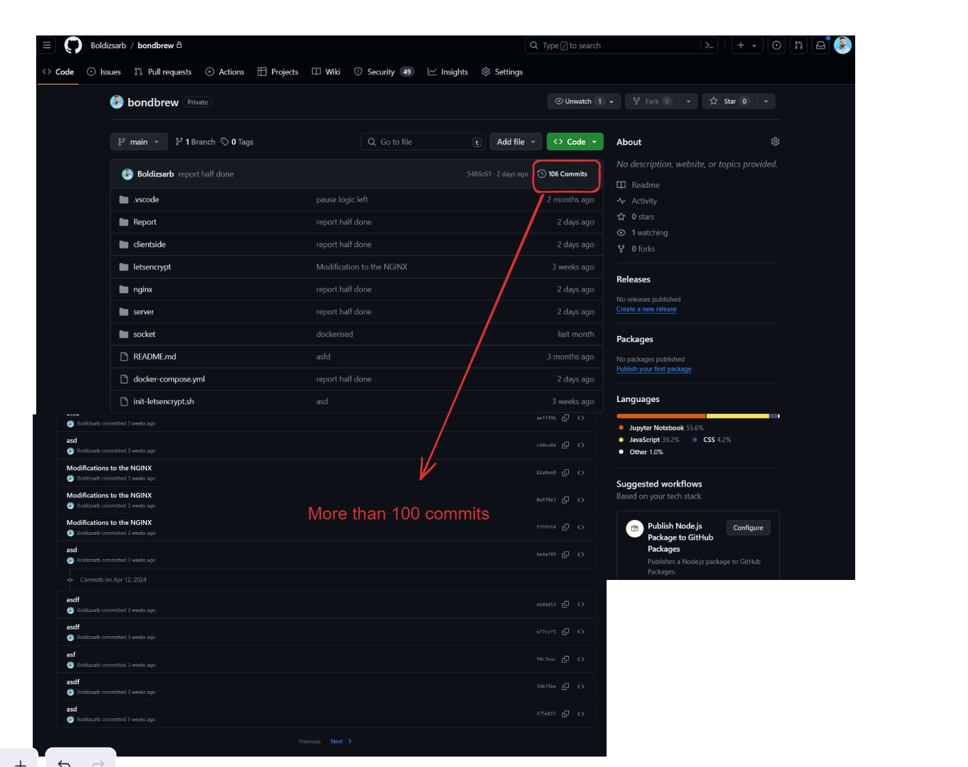

Please Not that

Please note that, taking a picture of all commits woult have crowded the report and knowing that the supervisor has full access to the reposatory, this diagram was deemed sufficient.

## Appendix B-2: Project timeline in a Ganth chart.

